NAMI COLLEGE
BSc (Hons) Computer Science
CSY2088 Group Project
Smart Cafeteria & Resource Queue Optimizer
A Progressive Web Application combining live queue management with Discrete Event Simulation

Final Group Report
Assessment Code: AS1
Submitted by: Group The OG
Smrit Chaulagain (Group Leader) - ID 20251105
Subham Khadka - ID 20251101
Abish Aryal - ID 20251007
Arpan Somnath Adhikari - ID 20251015
Dhirendra Singh Khadka - ID 20251025
Module Leader: Chewang Yolmoo
Submission Date: 7 October 2026

Declaration
We hereby certify that this report is our own work. Where the words or ideas of others have been used, they are marked with quotation marks and credited to their source.
We declare that this report describes original work that has not previously been presented for the award of any other degree at any other institution.
Group The OG
Smrit Chaulagain (Group Leader)
Subham Khadka
Abish Aryal
Arpan Somnath Adhikari
Dhirendra Singh Khadka
Date: 7 October 2026

Table of Contents
Declaration 2
1. Introduction 6
1.1 Problem Statement 6
1.2 Rationale and Proposed Solution 7
1.3 Aim and Objectives 7
1.4 Legal, Social, Ethical and Professional Considerations 8
2. Background Research and Comparative Study 8
2.1 Literature Review 8
2.2 Technology Review 9
3. Requirement Engineering 10
3.1 Requirement Collection 10
3.2 Requirement Analysis 10
3.3 Project Specification 11
3.3.1 Functional Requirements 11
3.3.2 Non-Functional Requirements 11
4. Methodology 12
4.1. Requirements collection and analysis 13
4.2. Design Approach 13
4.3. Development Approach 13
4.4. Testing Approach 14
4.5. Core modules 14
5.1 Database Design 15
5.2 User Interface Design 16
5.3 System Interaction Design 19
6. Prototype Implementation 24
6.1 Software Architecture 24
6.2 Technology Stack and Justification 24
6.3 Implementation Details 25
7. Testing 30
7.1 Unit Testing 30
7.2 Integration Testing 35
7.3 Customer Evaluation 37
8. Conclusion and Future Work 38
References 39
Appendix A — Individual Contributions and Reflections 40
Appendix B — Database Creation and Query Scripts 41
Appendix C — Source Code Extracts 45
Appendix D- Product Screenshot 51
Appendix E — Interview Questions 54

List of Figures

Figure 4.1 Agile methodology cycle
Figure 4.2 Project Gantt chart
Figure 5.2 Entity-relationship diagram
Figure 5.3 Student screen (low-fidelity wireframe)
Figure 5.4 Staff screen (low-fidelity wireframe)
Figure 5.5 Management screen (low-fidelity wireframe)
Figure 5.6 Use-case diagram
Figure 5.7 System architecture diagram
Figure 5.8 Sequence diagram — pre-order and ready notification
Figure 5.9 Activity diagram — order status lifecycle
Figure 6.1 Repository / project structure
Figure 6.2 Order in student portal
Figure 6.3 Order received in staff portal
Figure 6.4 Add items in menu
Figure 6.5 Staffing simulation input
Figure 6.6 Staffing simulation result
Figure 6.7 Staffing simulation report
Figure 7.1 Order state machine — illegal transition rejected
Figure 7.2 Privacy check — summarised figures only
Figure 7.3 Circuit breaker — fail-fast after three timeouts
Figure 7.4 Offline PWA shell
Figure 7.5 Role isolation — student blocked from staff board
Figure 7.6 Graceful degradation — DES offline fallback
Figure 7.7 Unit tests — DES client and test group
Figure 7.8 Unit tests — test group
Figure 7.9 Unit tests — test group
Figure 7.10 Unit tests — test group
Figure 7.11 Unit tests — test group
Figure 7.12 Unit tests — Python DES engine
Figure D.1 Product screens — Student App, Staff Order Board, Management Dashboard

List of Table

Table 1.1. How the queue problem affects each stakeholder group
Table 2.1 Comparison of existing approaches with the proposed system
Table 3.1 Stakeholders interviewed
Table 3.2 Functional requirements
Table 3.3 Non-functional requirements
Table 5.1 Main database tables
Table 7.1 Unit test results
Table 7.2 Integration test results
Table A.1 Individual contributions and reflections

1. Introduction
NAMI College cafeteria serves hundreds of students each day from which nearly all of the demands fall inside a short break, usually from 9:00 AM to 10:00 AM. During this time students wait around 15 to 20 minutes to be served. That wait is not just an inconvenience but it uses up the break that students would spend resting or studying, it crowds the cafeteria and the staff serves a rush they cannot predict. The counters work on their experience and guesswork because there is not a record of how the queue looked like the previous days.
The main cause of all of this is lack of proper data. Nobody has the data of the queue, no one knows whether to go to the cafeteria or wait for sometime before going. Staff in the kitchen does not know how many people are lined up and the manager cannot tell how many counters can properly handle the incoming queue.

1.1 Problem Statement
The core problem is the combination of large student demand within a limited timeframe with fixed serving capacity and the absence of data-driven queue system. This causes students to experience unnecessary waiting, staffs and the management faces unpredictable rushes and the lack of information to manage proper allocation of resources for the rush.

Who | What the problem looks like for them
Students | 15 to 20 minutes of wait times on a short break with no way to know if the queue is long or short.
Cafeteria staff | An unpredictable rush with no advance views of what comes next, no pre orders and no way to tell students if their food is ready other than shouting across the counter.
Cafeteria manager | No record of past queue data and no way to test any changes before committing to it.
College administration | Student dissatisfaction with a core campus service, and no figures to show whether it is getting better or worse.
Table 1.1: How the queue problem affects each stakeholder group

Addressing this problem for only one group does not work. That is why, we designed a system that considers the needs of all stakeholder groups so that improvements in one area do not create additional problem anywhere.

1.2 Rationale and Proposed Solution
This project developed a Smart Cafeteria and Resource Queue Optimizer to fill the gaps recognized previously. It uses a technology called Progressive Web Application (PWA) which is a website that behaves like an application and can run in any phone or laptop browser and requires no download from the app store. The app itself contains two things that helps to solve the problems faced by our stakeholders, they are:
• Live management: A shared view of the queue, menu, counters and pre-orders with different screens for student, staff and manager.
• Discrete Event Simulation(DES) : A model that tests and predicts how long the queue will take to clear and lets the manager test changes and it’s impacts before making them in real life.

1.3 Aim and Objectives
Aim: Design and build a Progressive Web Application that combines Discrete Event Simulation with live queues and order management for reducing student wait times at NAMI College cafeteria and to improve daily operations and give managers evidence based testing instead of guesswork.
Objectives:
1. Evaluate the problems faced during queue management faced by both students and staff during peak hours through user Q/A and observations.
2. Build a DES model for the cafeteria operations that consists of student arrival, service times and the use of proper staffing and counter resources.
3. Create a live monitoring feature that allows the user to see the queue length and estimated wait times.
4. Implement a prediction system that estimates wait-times and compares the simulation model with the live state of the cafeteria.
5. Develop a pre-ordering system for students, so that they can browse and order from the menu before the break and track their orders and be notified when it is ready.
6. Provide an admin dashboard for management with role-based access, performance reports and simulation testing of staffing and counter changes.
7. Test and evaluate the system with real users and find out if it has a good response on the student experience.

1.4 Legal, Social, Ethical and Professional Considerations
Data privacy and protection: The system collects data like name, email and hashes all of the passwords using bcrypt. Management reports contain no student identifiers as well.
Social responsibility and fairness: Everyone sees the same queue information at the same time. Pre-ordering is open to every student; there is no paid fast lane.
Accessibility: The application itself is a PWA so it runs on any browser and supports even a low-end device and requires no app-store for downloads. The interface has readable text sizes, good colour contrast and proper navigation.
Professional practice: Only free and open-source software like git and github are used for creating this program.

2. Background Research and Comparative Study

2.1 Literature Review
Recent work on campus dining falls into three parts: simulation studies, digital ordering systems, and the remaining gap.

Simulation studies
Usluer (2025) used DES to show that reallocating counters and staff can cut campus dining queues at low cost. Carbajal (2025) applied DES to size university dining resources under fluctuating demand. Debnath et al. (2025) validated dynamic staffing with SimPy and reduced average wait times. These studies support our use of a SimPy model for wait estimates and manager what-if tests.

Digital pre-ordering
UC Berkeley saw a big drop in lunch wait times after mobile ordering. The time went from roughly 45 minutes down to about 20 minutes (CampusIDNews, 2025). Other groups found similar results. Tianjin University of Science and Technology has reported the same kind of effect in 2024. MealPe said pre-order tools helped cut lines on campus in 2023. These findings point to building a PWA. With a PWA, students can place orders before they arrive. They can also view the queue status as it changes in real time.

Gap
Simulation tools are rarely given to managers for daily use, and pre-order apps do not answer “what if we open one more counter?” This project links both: a PWA for live queue and pre-orders, plus a DES layer for wait estimates and staffing tests.

Putting the two halves side by side shows a clear gap:
System type | Live queue | Pre-ordering | What-if simulation | Used daily by managers
University ordering apps | Partial | Yes | No | Yes
Commercial queue systems | Yes | No | No | Yes
Academic DES studies | No | No | Yes | No
This project | Yes | Yes | Yes | Yes
Table 2.1 Comparison of existing approaches with the proposed system
This project checks every box. It takes the practical value of pre-ordering through PWA and joins it to a live simulation layer that answers and helps to manage the planning. All of this was included in one application using the same data that was always available.

2.2 Technology Review
Discrete Event Simulation models a system that works as a sequence of individual events. Let’s give an example for a cafeteria the events can be: a student arrives, joins the ongoing queue, service starts, the service ends and finally the student leaves. We used SimPy for creating a DES that includes this as it is free and is well documented, light for running on a laptop. Some commercial alternatives are AnyLogic and Arena that carry licence costs and conflict with the requirements as well.
A Progressive Web Application was almost a requirement rather than a choice we made. While conducting student interviews it was clear that a student would not install an app from the app store for the cafeteria. A PWA exactly solves that issue as it requires no download, no account and almost no storage. Also a single codebase manages and serves all Android, iPhone and Desktop. So, it was a no-brainer to use this technology instead of creating a different app for each device.

3. Requirement Engineering

3.1 Requirement Collection
Requirements were gathered through interviews across all four of our stakeholder groups. Each of them sees the same problem from a different angle.
# | Stakeholder | Main interest
1 | Cafeteria Manager | Queue control, staff and counter planning, orders, reports
2 | Student | Wait times, menu, pre-ordering, tracking, notifications
3 | Cafeteria Staff | Incoming orders, queue load, order status, counter workload
4 | College Administrator | Student satisfaction, proper wait-time reports and resource use
Table 3.1 Stakeholders interviewed

Key findings: The managers needed a live view of queue stacks and a way to test staffing changes without discontinuing their service. The students needed something to check on the wait times before walking over to the cafeteria, pre-order and receive a notification when their orders were ready and it must work in phone browser without any downloads. Staffs needed a board showing incoming orders with their status and control over which counters are open. The administrator required summarised figures like average wait-times and average resolution rate.

3.2 Requirement Analysis
Five main findings shaped the design for our application. First, all stakeholders described the same problem independently, confirming that one system for all of the groups was the right call. Second, the student’s refusal to install an app settled the platform question which leads us to take the decision to go for the PWA. Third, the staffs revealed that pre-ordering alone might not shorten the queue. So, a proper order board the counter side is as important as the student side. Fourth, both manager and the admin asked for the ability to test changes which confirms that the simulation component is required for both and is a central requirement. Fifth, the administrator’s statement of management should not be able to see individual student orders became a privacy requirement that enforced our database design and this also makes the web app secure and private.

3.3 Project Specification

3.3.1 Functional Requirements
ID | Requirement | Priority
FR-01 | Students, staff and administrators shall log in with different permissions. | Must
FR-02 | Display the live queue length for the cafeteria. | Must
FR-03 | Show an estimated wait time based on current queue and DES model. | Must
FR-04 | Clearly marks wait times as estimates and not exact times. | Must
FR-05 | Show today's menu, prices and which counters are open for service. | Must
FR-06 | Students can browse the menu and place a pre-order before the break. | Must
FR-07 | Students can track their own order status and estimated pickup time. | Must
FR-08 | Notify the student when their order is ready for pickup. | Must
FR-09 | Staff should see an order board of incoming pre-orders and walk-in students. | Must
FR-10 | Staff shall update an order as received, preparing, ready or completed. | Must
FR-11 | Staff or manager can open or close a counter. | Must
FR-12 | Administrator shall run test simulations for staff numbers and counters. | Must
FR-13 | Administrator shall view a dashboard of wait time, queue length, pre-order use and staffing. | Must
FR-14 | Generate daily, weekly, monthly and semester performance reports. | Should
FR-15 | Students shall see the wait time without placing an order. | Should
FR-16 | Send a wait-time reminder before the main break. | Could
FR-17 | Administrators shall see summarised figures only, not individual orders. | Must
FR-18 | Student profile limited to own orders and account details. | Must
Table 3.2 Functional requirements with Must, Should and Could priority

3.3.2 Non-Functional Requirements
ID | Category | Requirement
NFR-01 | Platform | PWA that works in mobile or desktop browsers without installation through the appstore.
NFR-02 | Usability | Student screens are easy to read on a phone during a short break.
NFR-03 | Performance | Live queue length and wait-time figures update quickly enough to be current.
NFR-04 | Real-time | Order status and queue changes appear without refreshing the page.
NFR-05 | Security | Role-based access. Students see only their own orders.
NFR-06 | Privacy | Only necessary data collected. College-level reports use summarised figures.
NFR-07 | Transparency | Wait-time predictions labelled as estimates.
NFR-08 | Accessibility | Works across devices and follows basic accessibility guidelines.
NFR-09 | Reliability | If the prediction model cannot produce a figure, still show live queue length.
NFR-10 | Maintainability | Menu items, prices, counters and staff editable without code change.
Table 3.3 Non-functional requirements

4. Methodology
The project will use the Agile method. Requirements may change based on feedback, so the work will be done in short cycles with regular review.

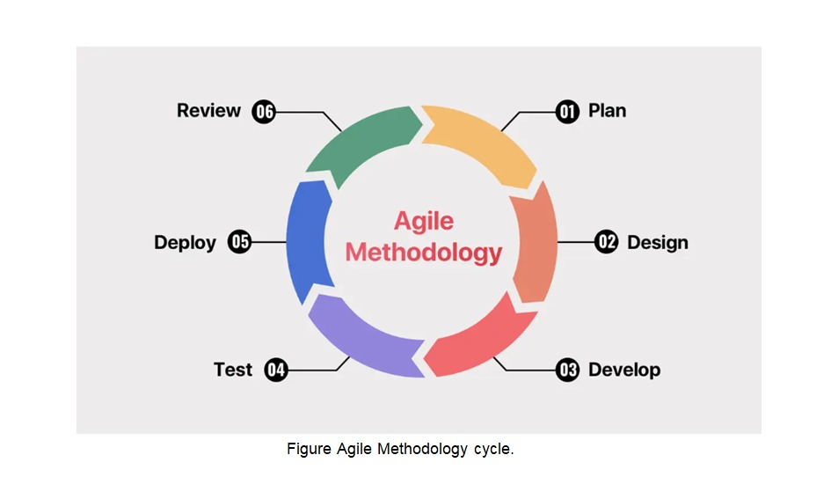
Figure 4.1 Agile Methodology cycle

The six main phases are:
- Planning – Collect requirements from students, staff, and administrators.
- Design – Create system design, database structure, UI designs (Figma), and UML diagrams.
- Development – Build features in short sprints, starting with core functions.
- Testing – Test continuously and run user acceptance tests.
- Deployment – Put the system on a staging server for pilot use.
- Review – Collect feedback and measure results against the objectives.

4.1. Requirements collection and analysis

Requirements were collected with the help of interviews with four groups: students, cafeteria staff, the cafeteria manager, and college administration. Every group mentioned the same rush-hour problem. After the interviews, there were two types of requirements which were functional requirements, non-functional requirements and stored the list with MoSCoW(Must, Should, or Could). Two things came out from the analysis. One was that the system must work in a web browser. People should not have to install an app. It should use a PWA. The other item was about privacy. The management reports must not show individual student IDs.

4.2. Design Approach

Design followed the prioritised requirements. The database was designed as a relational MySQL database consisting of two privacy views and foreign keys. Low fidelity wireframes were created to test user interfaces, which were split into three screens(student, staff, manager). Use case diagrams and four-layer architecture(presentation, application, simulation and data) were created to define the system interaction.

4.3. Development Approach
Implementation used five periods:

- Foundation and observation data
- Live queue and DES connection
- Pre-order flow, staff order board, and counter control
- Management dashboard and what-if simulation
- authentication , security, PWA service worker, and deployment

Every period delivered a working part that could be tested before the next one started. The frontend used Svelte, the API used Express and Socket.io, the database used MySQL, and the simulation engine used Python/SimPy as a separate service.

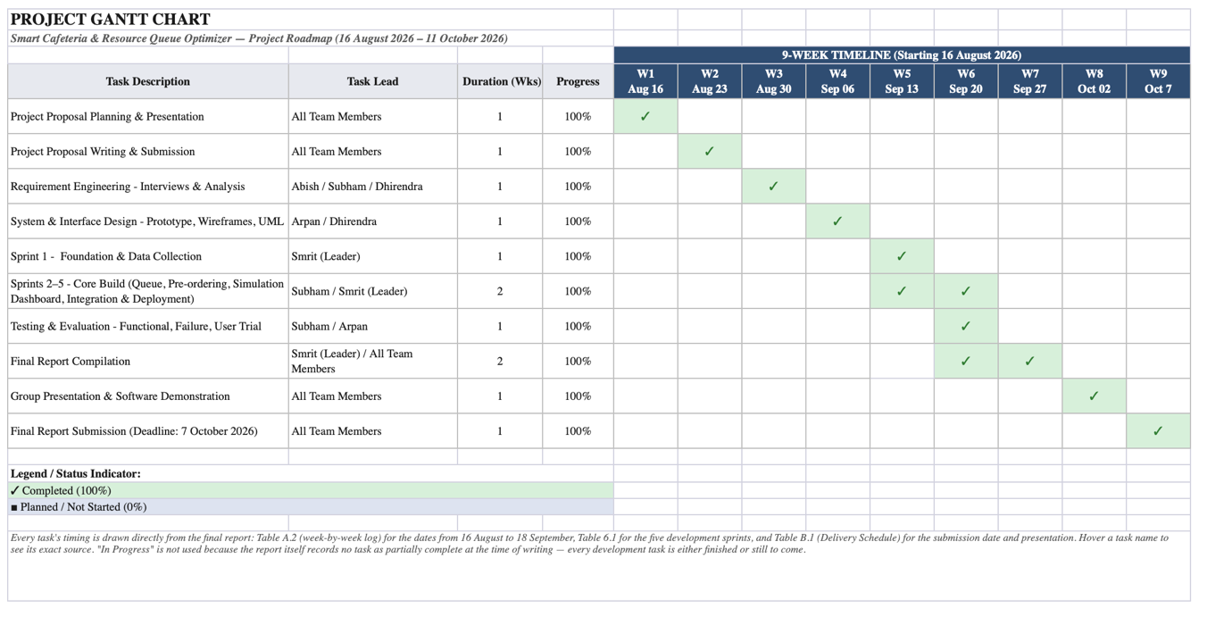
Figure 4.2 Project Gantt Chart

4.4. Testing Approach
Unit tests checked single functions(login, role checks, order status, wait estimates, circuit breaker). Integration tests checked full flows(pre-order lifecycle, live updates, role isolation, fallback when the simulation engine is offline). A short trial with volunteer students and staff gave feedback on usability.

4.5. Core modules
After requirements analysis, the system was divided into these core modules:

Module | Responsibility
Authentication | Login, JWT, role-based access
Queue & wait estimate | Live queue length, DES wait estimate, Offline fallback
Menu & pre-order | Menu, place order, track status, ready notification
Staff order board | Incoming orders, status updates, open/close counter
Management dashboard | KPIs, menu/counters, summarised reports
Simulation service | Wait estimates, what-if scenarios, self-calibration
Real time layer | socket.io for queue, order, and counter update

These modules map to the Must-have requirements and were built and tested period by period.

5. Design of the Proposed System

5.1 Database Design
The database used is MySQL as it is a relational database and the schema is built around eight tables and two reporting views. This design follows the requirements exclusively.
Table | What it holds | Key points
users | Accounts for all roles | Role is an enumerated column. Only bcrypt hash of password stored.
menu_items | Dishes, prices, availability | Editable from management screen (NFR-10).
counters | Physical serving points | Each carries a service profile (standard, fast, pre-order).
orders | One row per order + status | Status: received → preparing → ready → completed. Separate timestamps.
order_items | Dishes within an order | Stores unit price at time of ordering.
queue_observations | Periodic queue snapshots | Records open counters and estimate sources.
simulation_scenarios | Saved what-if runs | Parameters and results stored as JSON.
service_events | Measured service times | Sample the simulation model calibrates against.
Table 5.1 main database table

Relationships are enforced with foreign keys. Two privacy views, v_peak_hour_performance and v_prediction_accuracy, expose only summarised figures and never student IDs.
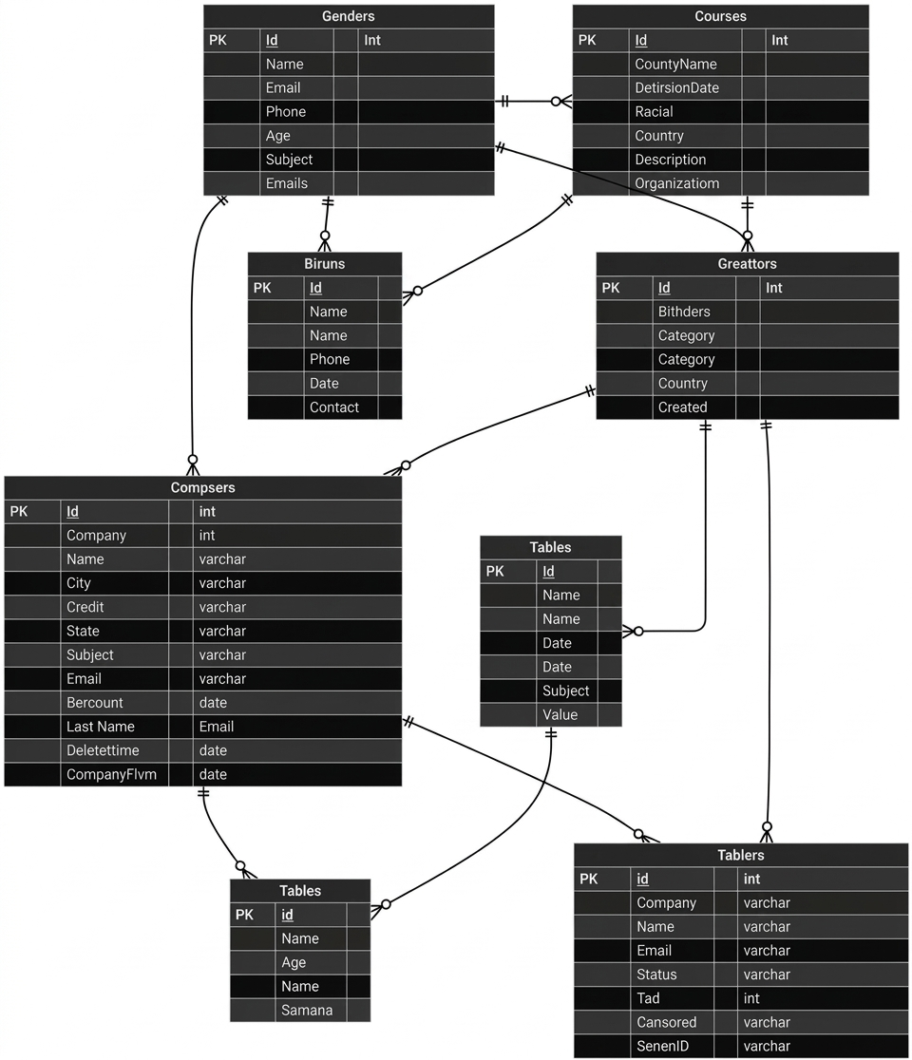
Figure 5.2 entity relation diagram

5.2 User Interface Design
Three user interfaces were designed, one per each role and each of them shaped by how much time that person has and what they are trying to achieve.

Student screen
A plain queue banner at top that shows current queue length and estimated wait times. Below that there is a menu with respective prices and which counters are open. This contains a simple order flow, and an order card that updates itself. When the simulation engine is not working the banner adds an approximate and also states that the simulation engine is offline. When the live connection drops it also displays reconnecting so that the students know if they have disconnected from the site or not.

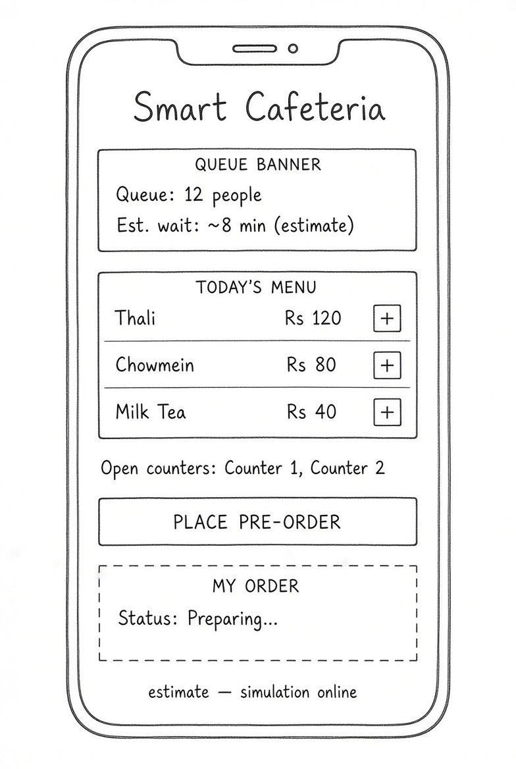
Figure 5.3 student screen

Staff screen
Order board lists incoming orders with large status buttons and a simple toggle button for opening and closing a counter. Nothing else is added here as this is the core thing that helps them focus as well so no distractions are added.

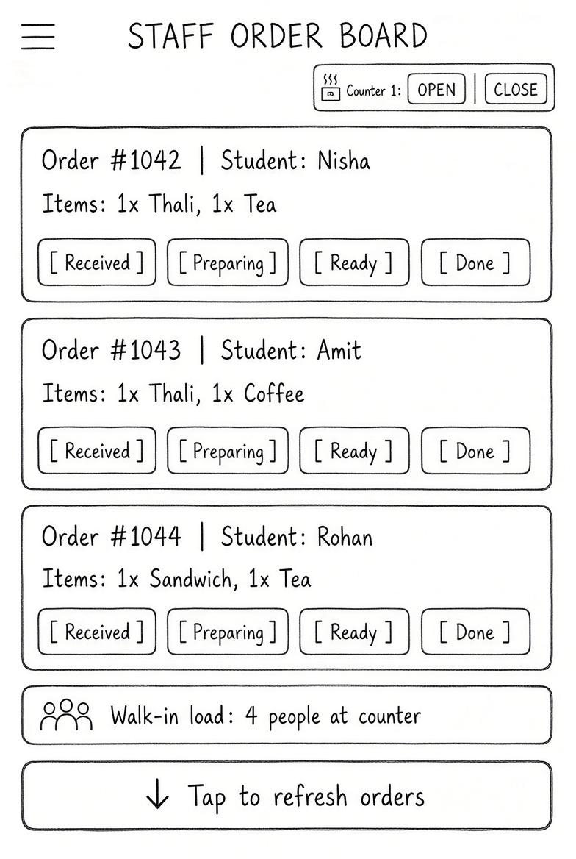
Figure 5.4 staff screen

Management screen
It includes a summary of key indicators like average wait time, longest queue, share of pre-orders, staff utilisation, menu and counter management and the simulation panel for testing scenarios. The panel checks if the engine is available or not before the manager starts testing scenarios.

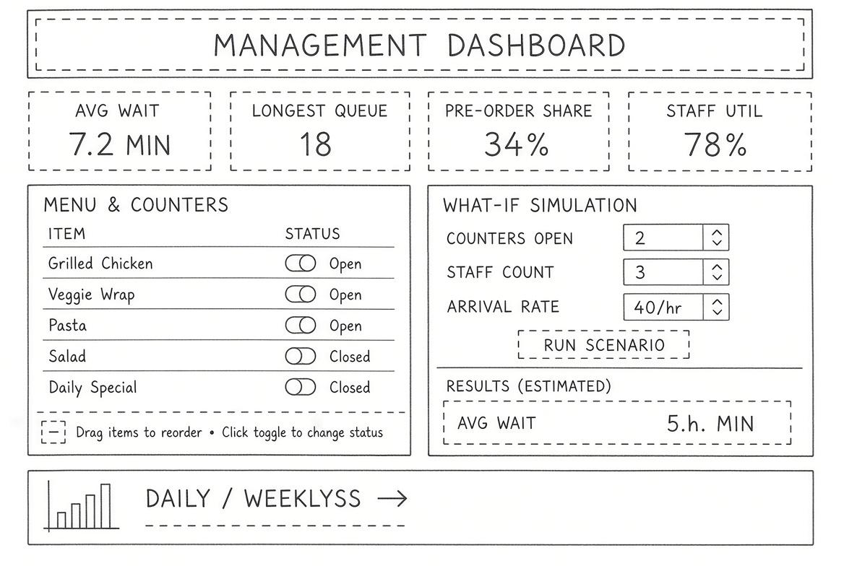
Figure 5.5 Management screen

5.3 System Interaction Design
Use-case diagram
The use-case diagram shows how the four actors work with the Smart Cafeteria system:
- Student — view the queue, get wait estimates, place pre-orders, track orders, and receive alerts
- Staff — manage the order board, update order status, and open or close counters
- Manager — use the live dashboard, run simulations, view analytics, and export reports
- System — generate predictions, send notifications, update queue data, and self-calibrate the simulation model in the background
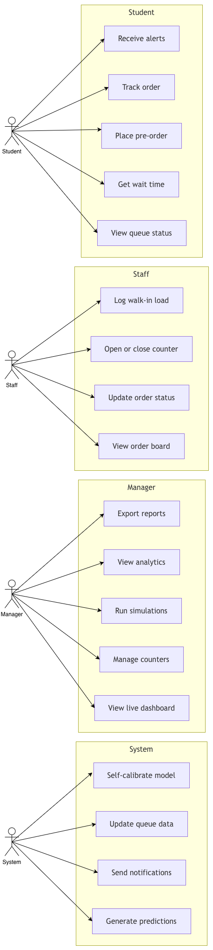
Figure 5.6 uses case diagram

System architecture diagram

The app is built in four layers:
- Presentation — Svelte PWA with role-based screens (Student, Staff, Manager) and live updates via Socket.io

- Application — Express handles login, the order state machine, and API calls; a circuit breaker is used if the simulation service is offline

- Simulation — Python/SimPy estimates wait times, runs what-if scenarios, and periodically calibrates itself by reading service times from MySQL (it never writes back)

- Data — MySQL stores all data, including the privacy views v_peak_hour_performance and v_prediction_accuracy, which show only summarised figures and no student IDs

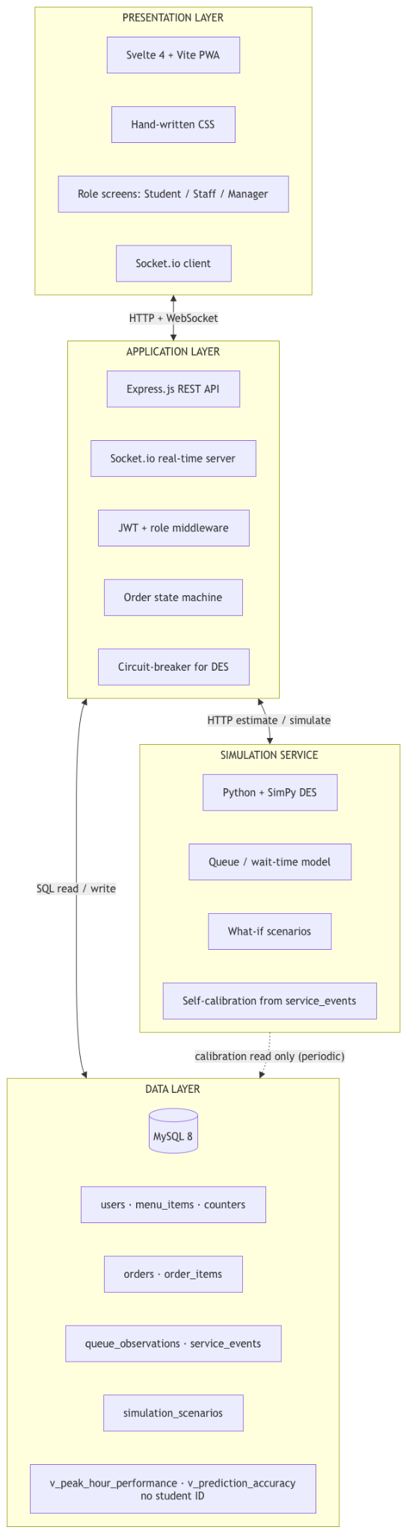
Figure 5.7 System Architecture diagram

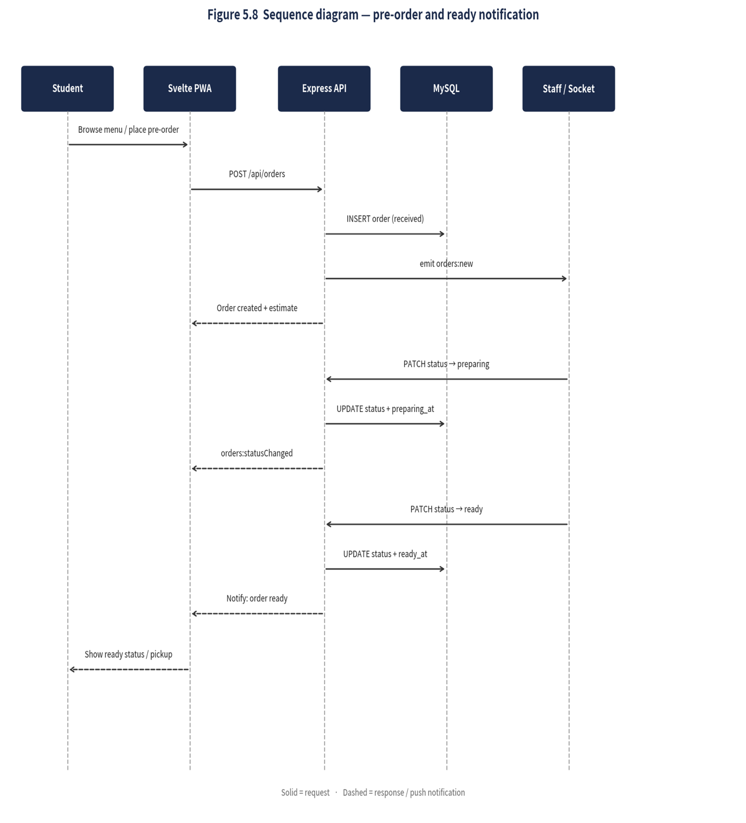
Figure 5.8 Sequence Diagram pre-order and ready notification

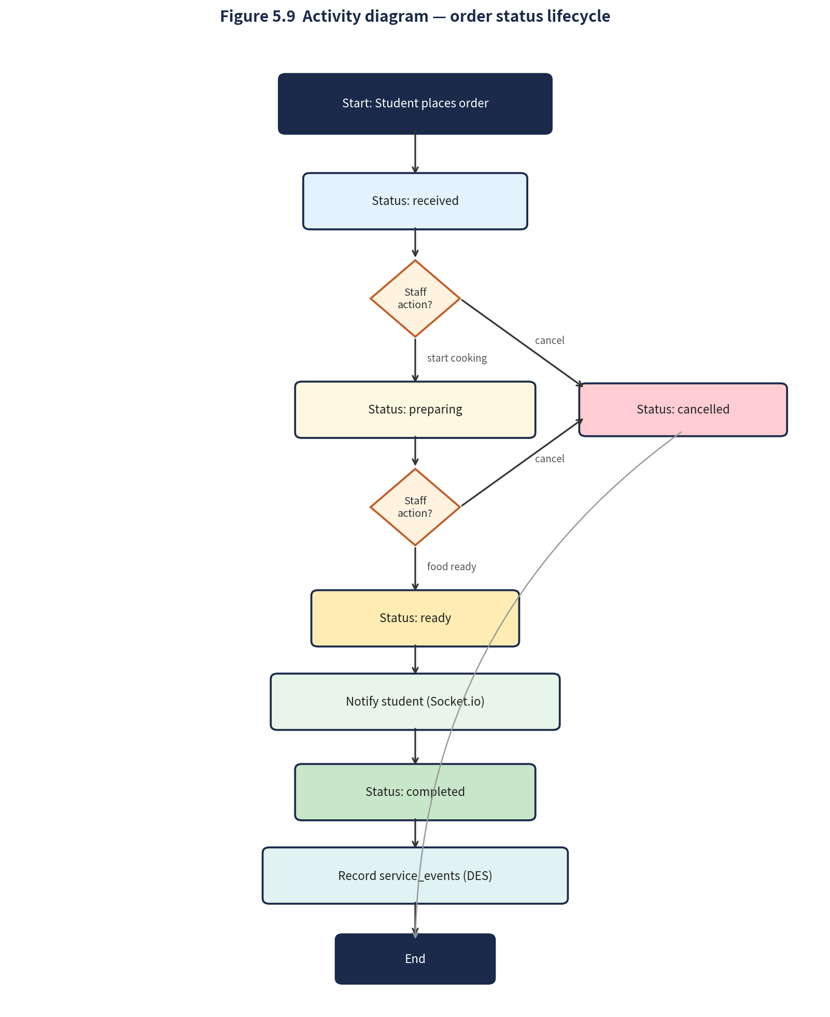
Figure 5.9 Activity diagram Order status lifecycle

6. Prototype Implementation

6.1 Software Architecture
The system uses three-tier architecture with the simulation engine as a fourth service.
Tier | Component | Port | Responsibility
Presentation | Svelte PWA (Apache) | 80 | All of the screens the user sees. Role-aware frontend.
Application | Express.js + Socket.io | 4000 | Business rules, authentication, live broadcasting.
Data | MySQL via Docker / Docker Compose | 3306 | Users, menu, counters, orders, queue history, scenarios.
Simulation | Python/Flask + SimPy | 5001 | Wait-time estimation and test scenario run.
Table 6.1 The four running services
The simulation engine runs as a different service so it stays between calls and can be restarted independently and it enables graceful degradation so that if the engine stops, the API falls back and the app keeps on working. It listens only on the local machine. Also, the authentication lives in the Node API.

6.2 Technology Stack and Justification
Layer | Technology | Why chosen
Frontend | Svelte 4.2 + Vite 5.3 | Complies easily and is fast with no runtime. It is important for running smoothly on low-end devices.
Styling | Hand-written CSS + tokens | Smaller download size and has a consistent look throughout the site.
Backend API | Node.js + Express 4.19 | Simple REST API with large ecosystem and uses the same language as frontend.
Live updates | Socket.io 4.7 | For live changes as it pushes queue and order changes instantly.
Database | MySQL 8 (Docker / Docker Compose) | Relational database with proper relationships and easy to run and start.
Authentication | JWT + bcrypt | Stateless token carrying and standard password hashing for data protection.
Simulation | Python + SimPy 4.1 + Flask | SimPy runs the model; Flask exposes it as a service.
Table 6.2 Technology stack and justification

6.3 Implementation Details
Development was done in five sprints which consisted of establishing the foundation and collection of observation data. Delivering core queue management and DES connection, adding the pre-ordering lifecycle with staff order board and counter toggle, management dashboard with testing simulations and finally authentication with security rules and PWA service worker and deployment scripts.
Frontend: Svelte with a service worker was used. Static assets are cached first while the API requests are never cached. Live updates arrive over Socket.io and when the connection drops the application tells the users about that and it polls more frequently so users can see the estimated wait times and queues.
Backend: Every route is protected using JWT verification and role checked by the middlewares. Order status uses proper states like received → preparing → ready → completed. The simulation engine is connected through a single module that applies timeouts, circuit breaker in case it fails and clear distinction between parameter errors and engine down error.
Simulation engine: It is used for getting live wait estimation and the engine itself seeds a SimPy model with students currently in queue and runs eight short replications. If it does not answer within 1.5 seconds the API falls back to a simple calculation label which is in the backend and gives the result. Test scenarios use its full model with service times, arrival times, staff-limited counters and common random numbers across compared scenarios. The model itself calibrates every ten minutes from the service_events table.
Deployment: The deployment uses Docker Compose. Four containers launch at once: MySQL 8 (with schema and seeding on first boot), the Express API with its built-in Svelte PWA, the SimPy DES engine, and Adminer for viewing the database. A single docker-compose up command will build the necessary images if they don’t exist yet, wait for MySQL to become available, and launch the rest.

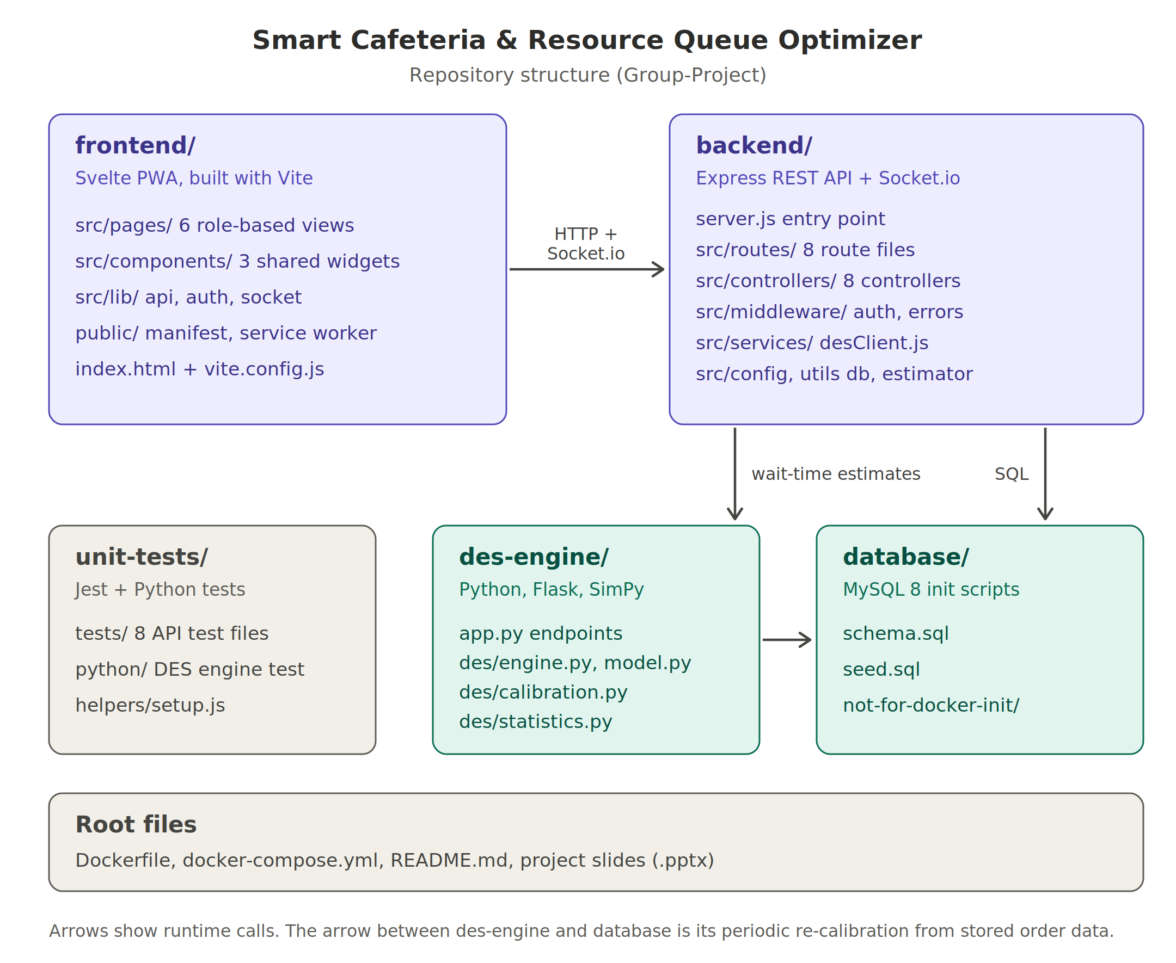
Figure 6.1 – folder/repo structure

Implementation evidence is shown in Figures 6.2–6.7: student order, staff order board, menu management, and staffing simulation.

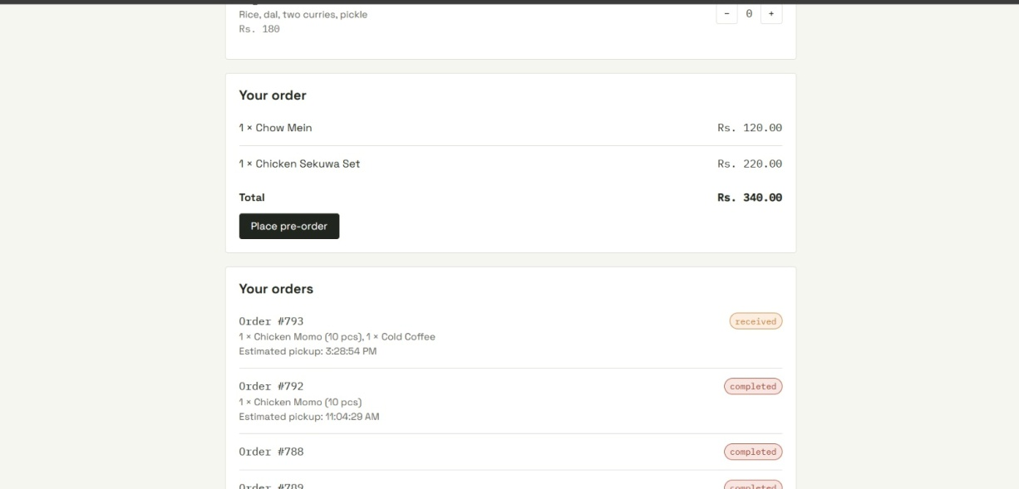
Figure 6.2 – Order in student portal

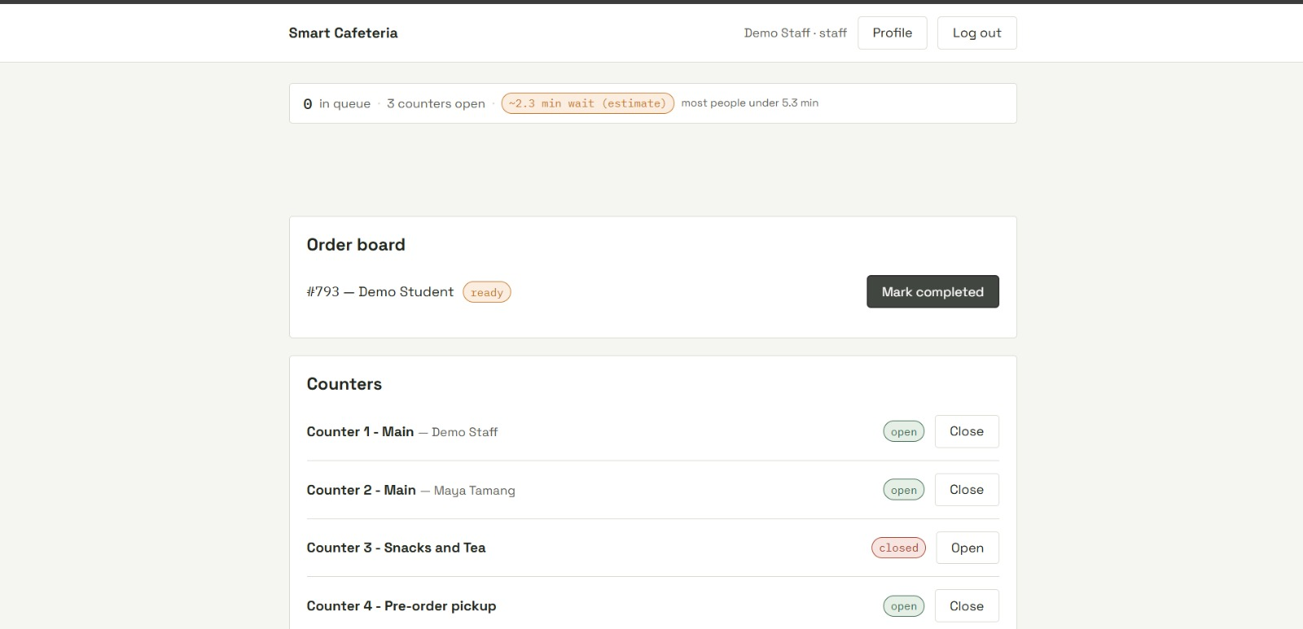
Figure 6.3 – Order received in staff portal

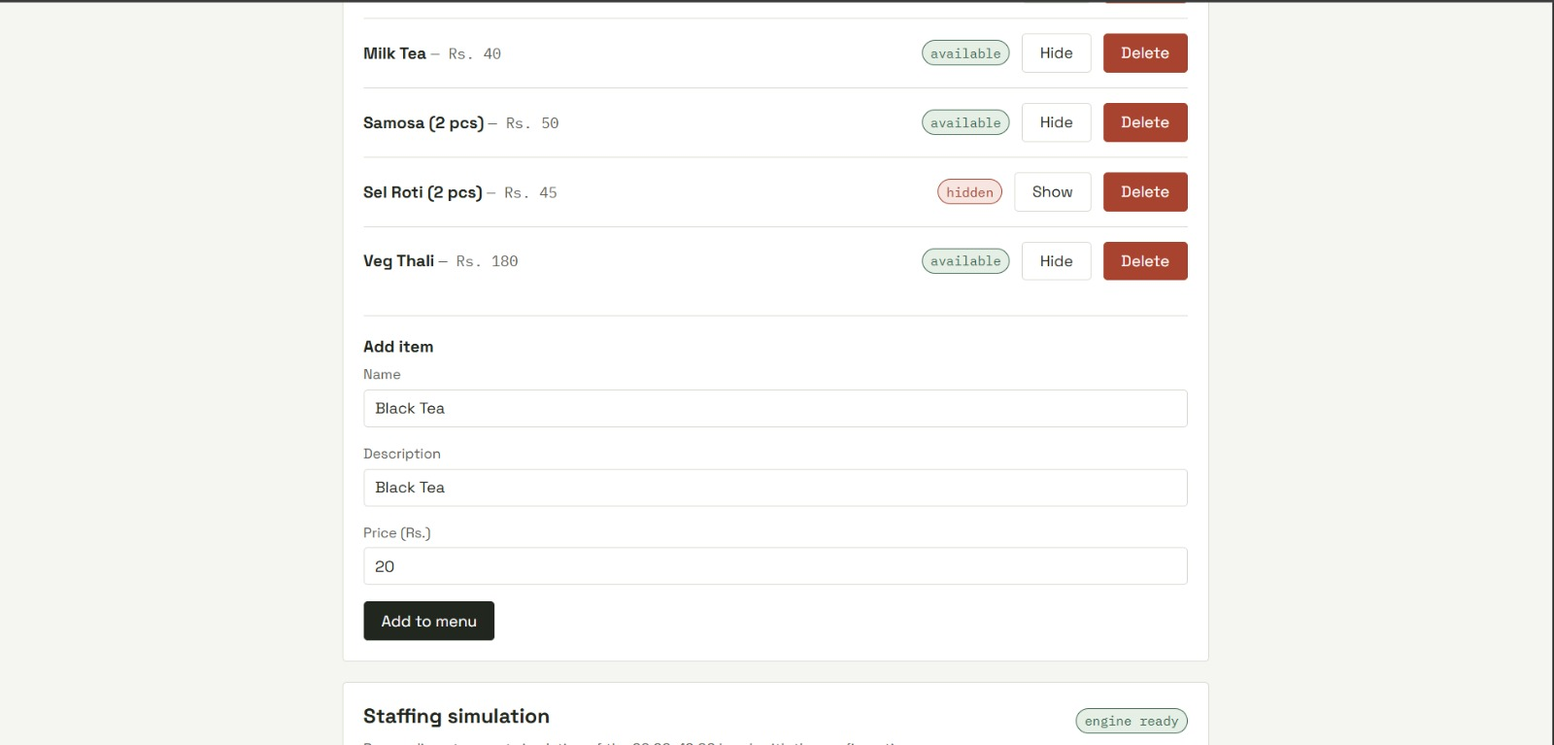
Figure 6.4 – Add items in menu

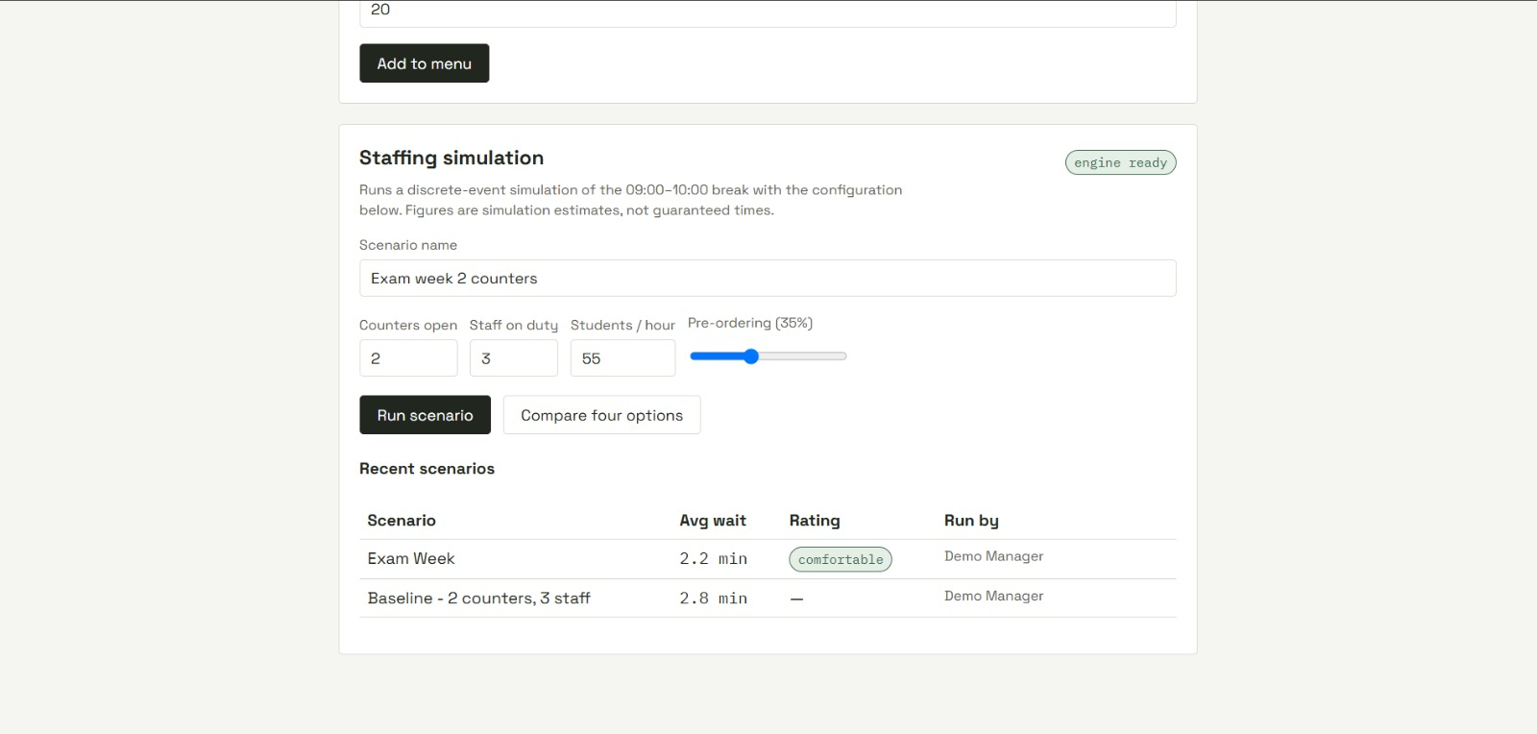
Figure 6.5 – staffing simulation

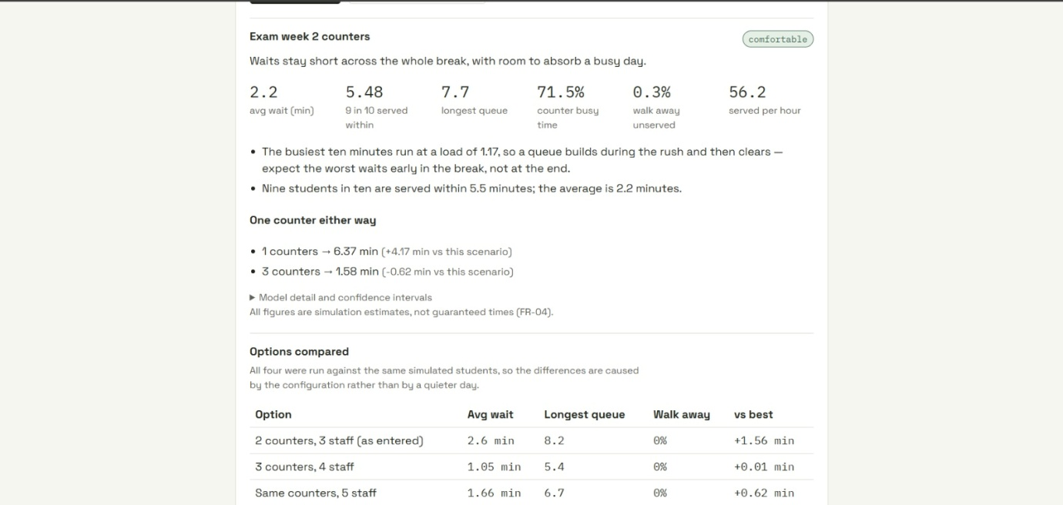
Figure 6.6 – staffing simulation report

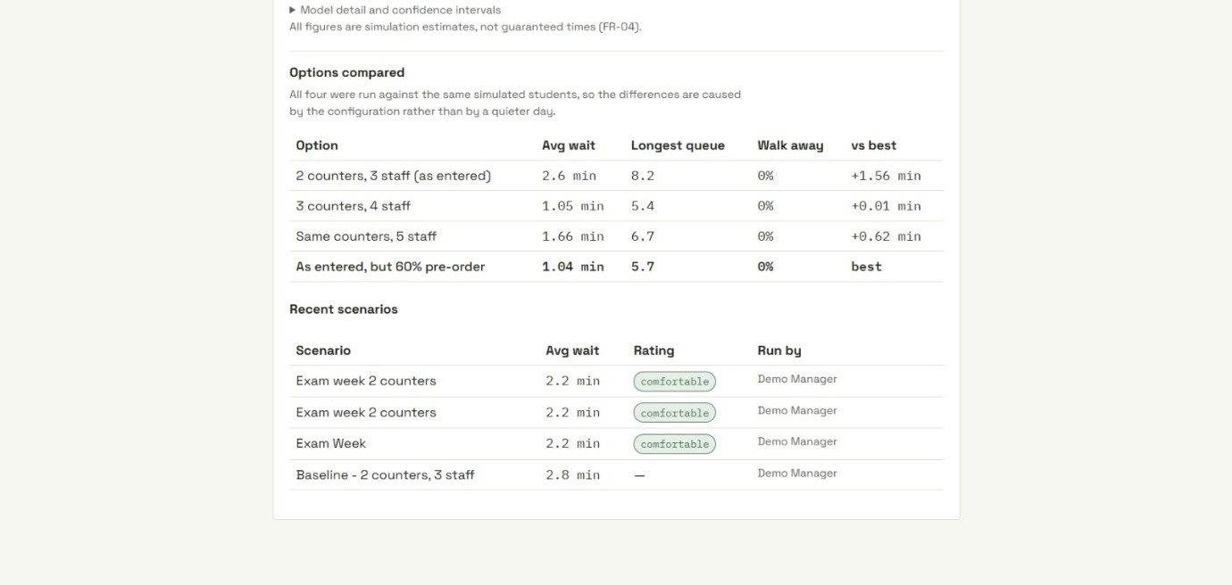
Figure 6.7 – staffing simulation report

7. Testing
The tests were conducted and the brief is reported below with customer evaluation.

7.1 Unit Testing
Unit tests were automated and executed in the unit-tests/ directory on a per function basis with expected behaviour checked. One such test case example is listed below.

ID | Function under test | Input / Action | Expected output | Actual output | Result
UT-01 | login(role) | Valid credentials for each of 4 roles | Redirect to role-specific screen | Redirected correctly | Pass
UT-02 | checkRole(token, required) | Student token on staff endpoint | 403 Permission error | 403 returned | Pass
UT-03 | getQueueLength() | 3 orders in received/preparing | Queue length = 3 | 3 returned | Pass
UT-04 | estimateWait(queue, counters) | Queue=6, counters=2, avg service=2.5 min | Estimate ≈ 7.5 min, labelled | 7.5 min, labelled | Pass
UT-05 | placeOrder(student, items) | Valid menu items, student logged in | Order status = received + pickup estimate | received + estimate | Pass
UT-06 | updateOrderStatus(id, next) | received → preparing | Status updated, preparing_at set | Updated correctly | Pass
UT-07 | updateOrderStatus(id, next) | completed → preparing (illegal) | Rejected by state machine | Rejected | Pass
UT-08 | toggleCounter(id, open) | Close counter 2 | Counter closed; reflected on all screens | Closed + broadcast | Pass
UT-09 | runScenario(params) | 2 counters vs 3 counters | Avg wait + CI for both | Results with CI | Pass
UT-10 | getReport(admin) | Admin token | Summarised figures only; no student IDs | No personal data | Pass
UT-11 | fallbackEstimate() | Simulation engine stopped | Queue length shown; "approximate" label | Fallback + label | Pass
UT-12 | hashPassword(pw) | Plain-text password | bcrypt hash (not reversible) | Hash produced | Pass
Table 7.1 Unit test results

Unit test: a finished order can't go back to "preparing". The server rejects it (400).

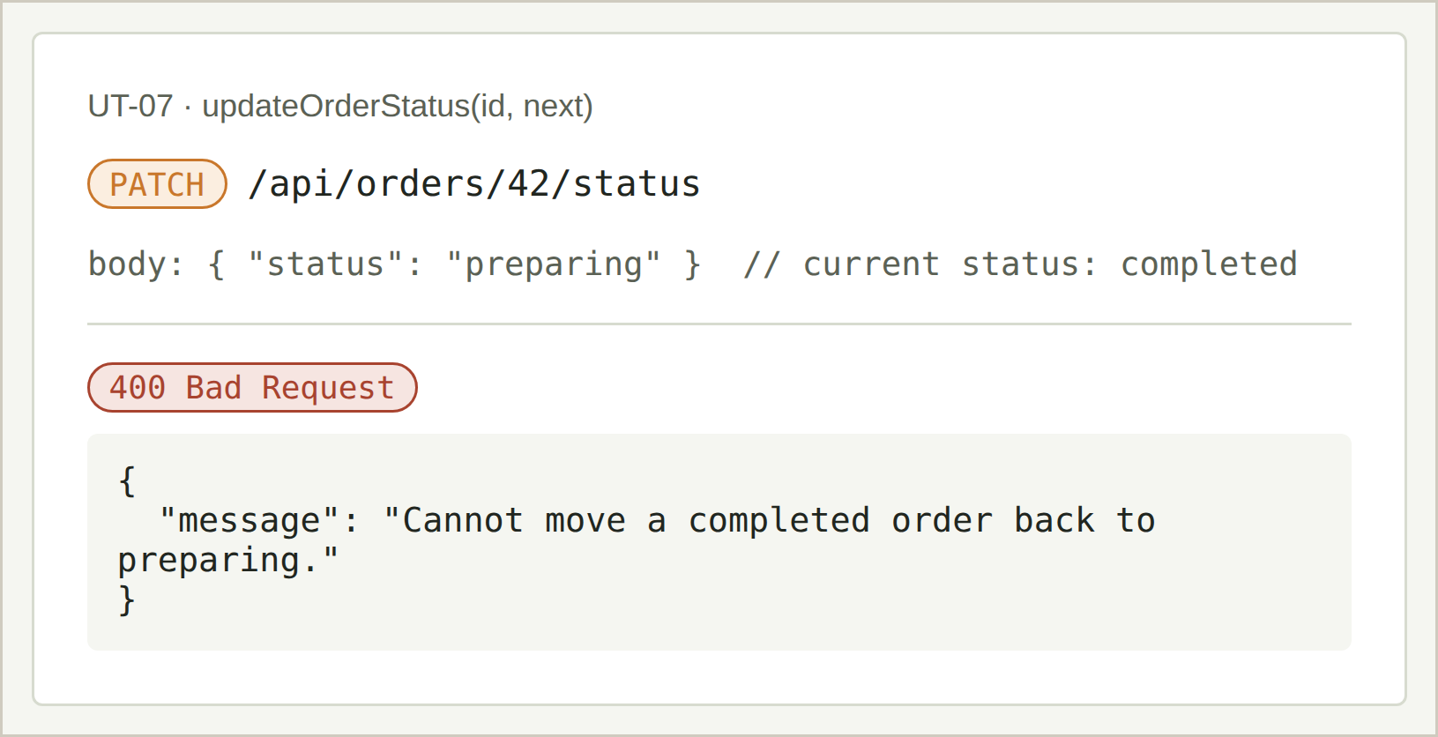
Figure 7.1 Order state machine — illegal transition rejected

Privacy test: no student or individual order record is shown only.
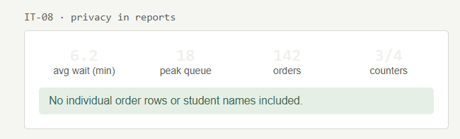
Figure 7.2 Privacy check — summarised figures only

Circuit breaker: after 3 timeouts the circuit opens; attempt 4 is rejected in 2 ms.
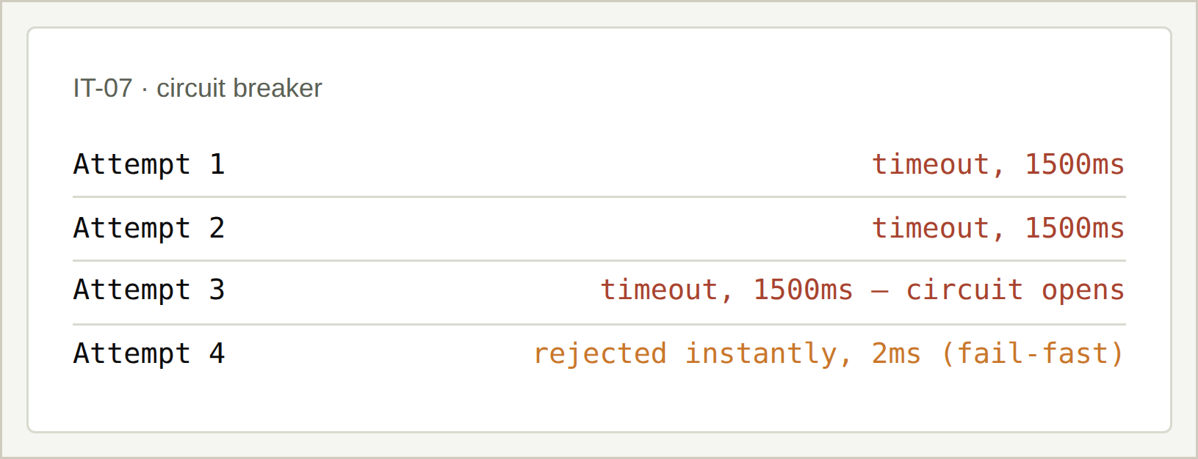
Figure 7.3 Circuit breaker — fail-fast after three timeouts

Automated unit-test runs from the unit-tests/ suite are shown in Figures 7.4–7.10
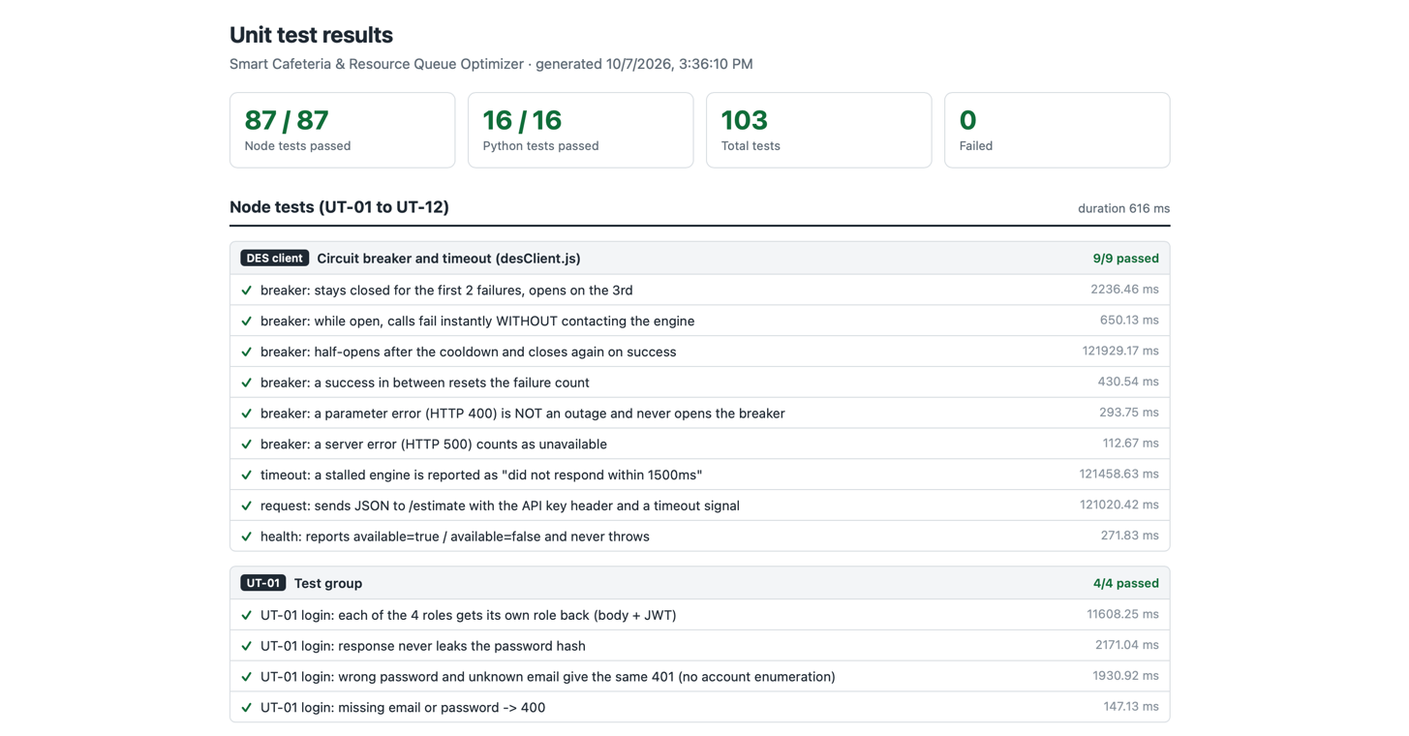
Figure 7.4 Unit testing- des client and test group

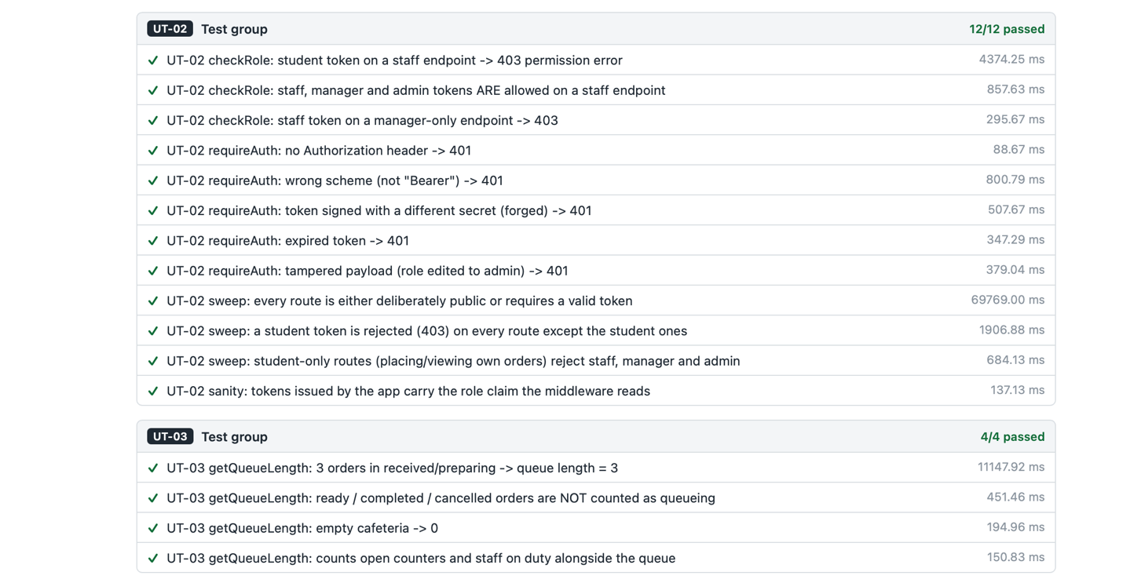
Figure 7.5 Unit testing- test group

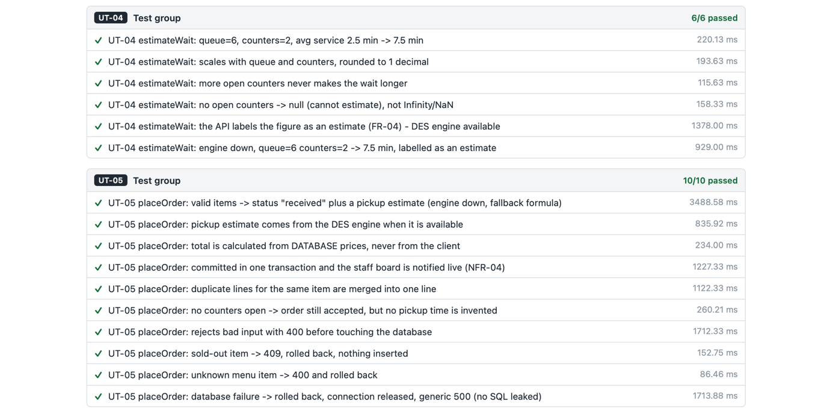
Figure 7.6 Unit testing- test group

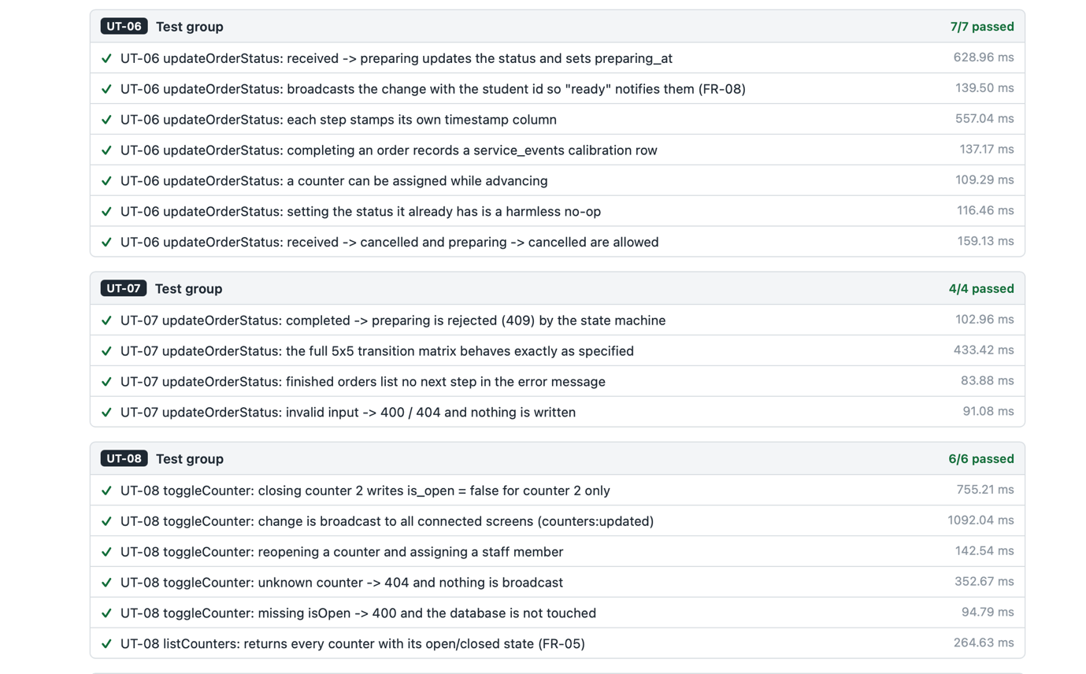
Figure 7.7 Unit testing- test group

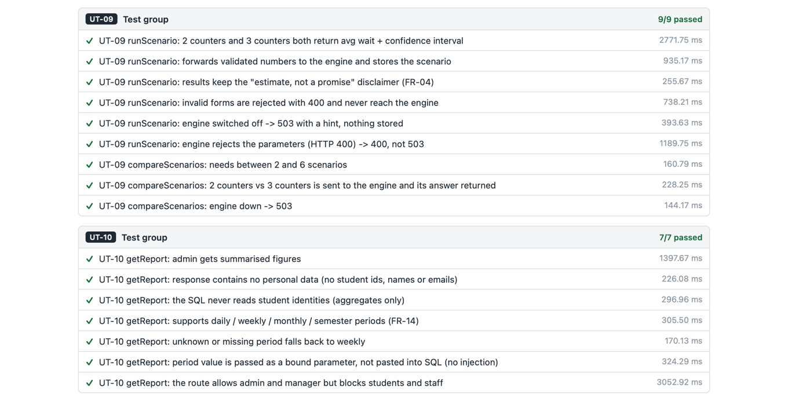
Figure 7.8 Unit testing- test group

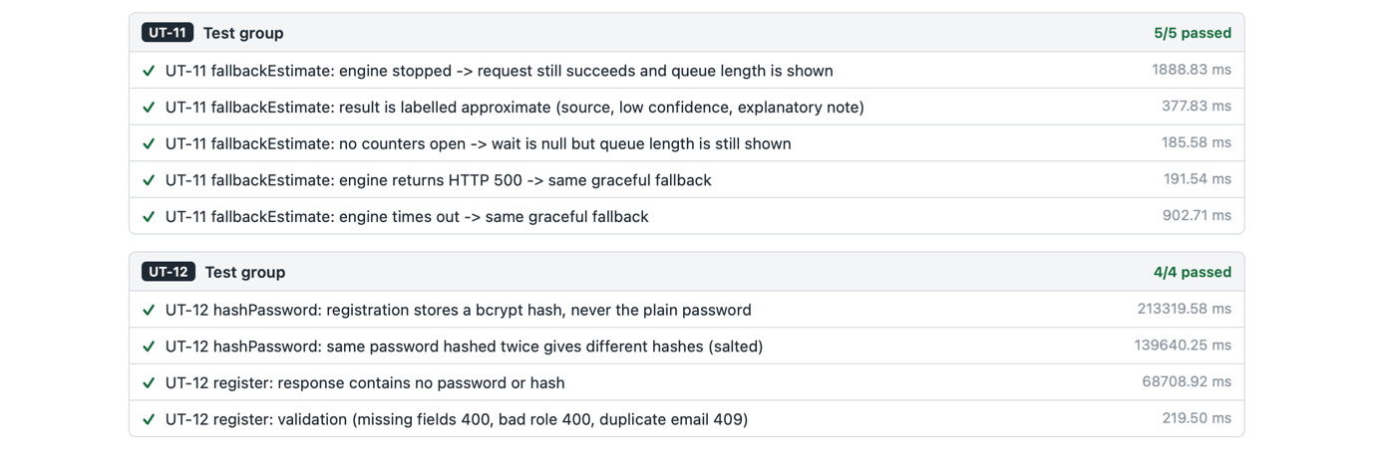
Figure 7.9 Unit testing- test group

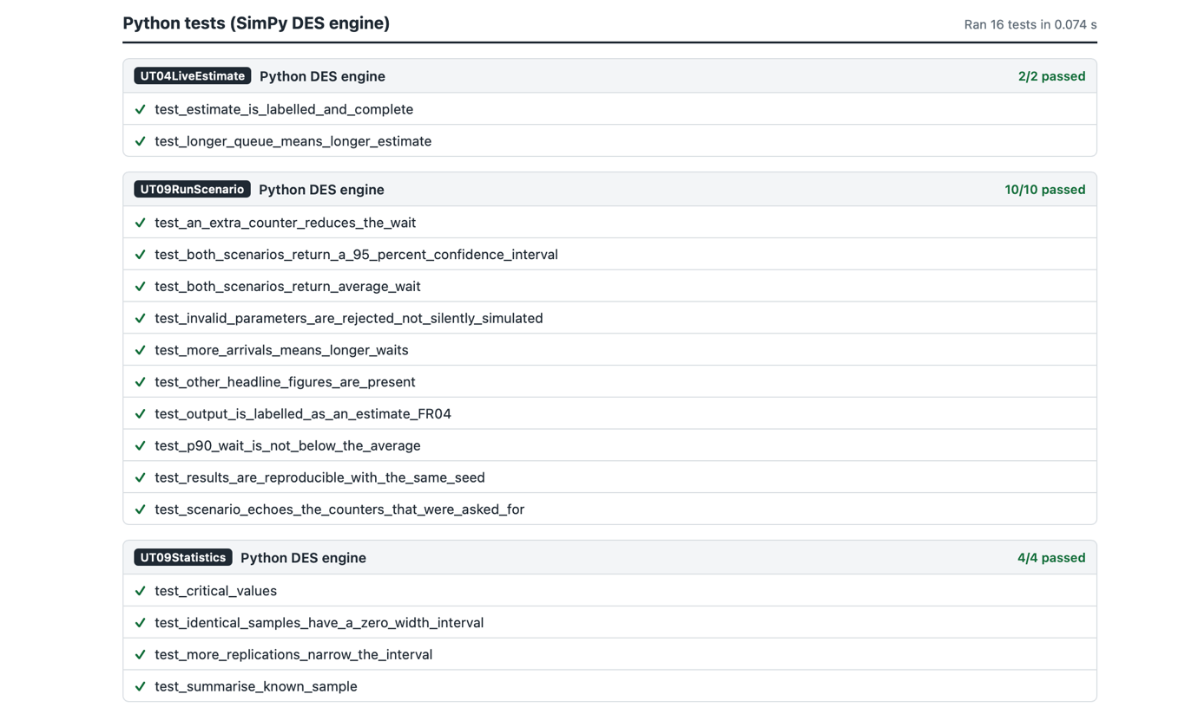
Figure 7.10 Unit testing- python des engine

7.2 Integration Testing
Integration tests were done to verify if the functions work correctly across the application.
ID | Scenario | Steps | Expected outcome | Actual outcome | Result
IT-01 | Full pre-order lifecycle | Student places order → staff advances status → student notified | Order appears on the staff board; student screen shows updates live and notification when ready. | All steps succeeded | Pass
IT-02 | Live queue + estimate | Place several orders; open student view on second device | Queue banner shows correct count + estimate without refresh | Correct + live | Pass
IT-03 | Role isolation | Student attempts staff and management URLs/API | All requests rejected and student remains on own screen | Rejected | Pass
IT-04 | Counter open/close propagation | Staff closes a counter | Student and management screens update immediately via Socket.io | Updated live | Pass
IT-05 | What-if simulation end-to-end | Manager runs scenario with 2 then 3 counters | Both return average wait, queue length and confidence intervals | Results returned | Pass
IT-06 | Graceful degradation | Stop simulation engine; reload student view | Queue length still shown and wait marked approximate. | Fallback worked | Pass
IT-07 | Circuit breaker | Stop engine; make repeated estimate requests | After 3 failures subsequent requests fail fast. | Fail-fast observed | Pass
IT-08 | Privacy in reports | Admin opens management report | Only summarised figures and no individual order rows visible | No personal data | Pass
IT-09 | Offline PWA shell | Install to home screen; open offline | Usable shell stating live data unavailable | Shell + message | Pass
IT-10 | Menu edit without code | Admin adds menu item and assigns staff | Changes visible immediately on student and staff screens | Live update | Pass
Table 7.2 Integration test results

Installed on the home screen and opened offline: a usable shell that says live data is unavailable.
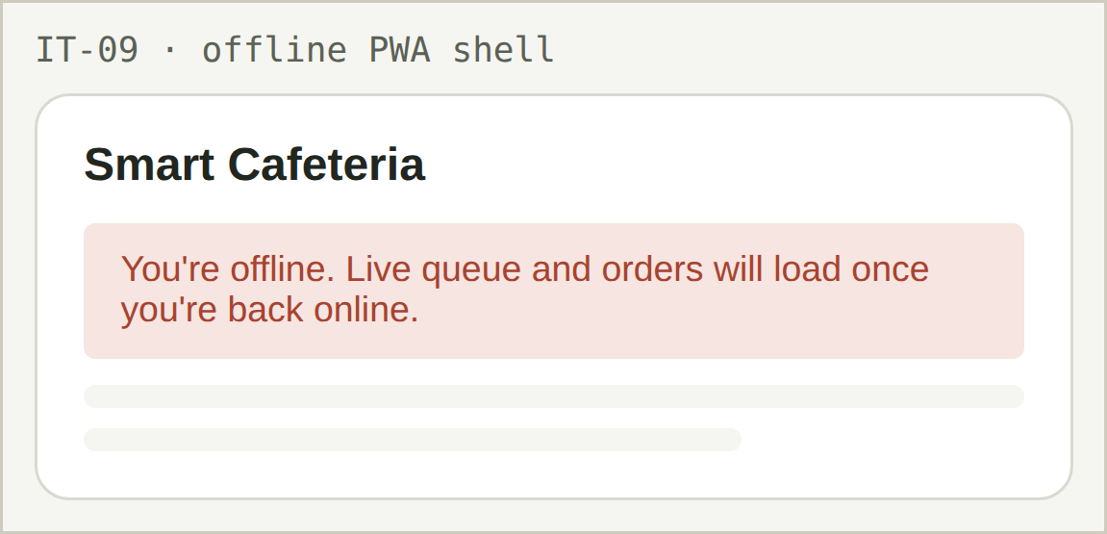
Figure 7.4 Offline PWA shell

Integration test: a student opening the staff board is blocked.

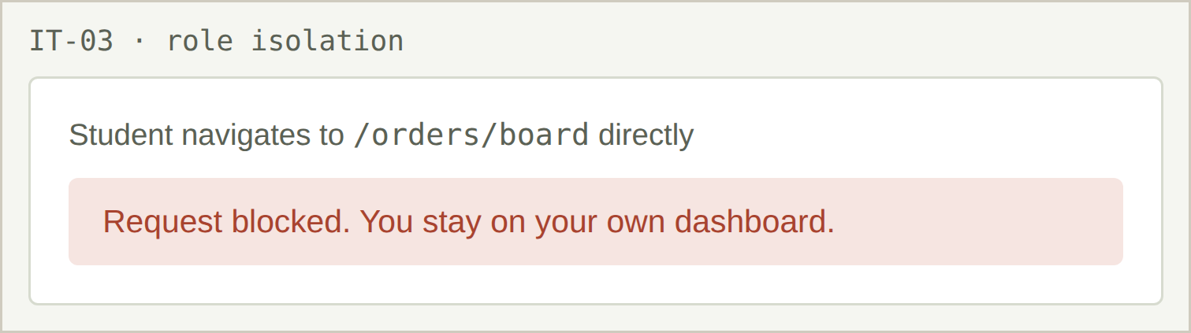
Figure 7.5 Role isolation — student blocked from staff board

Simulation engine stopped: queue length still shows, wait marked approximate.

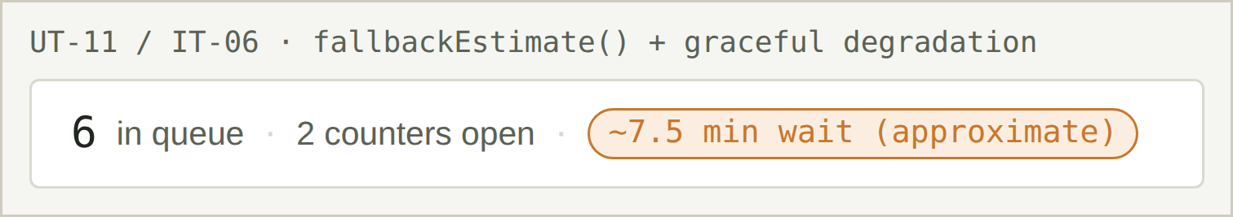
Figure 7.6 Graceful degradation — DES offline fallback

7.3 Customer Evaluation
A limited trial was run with volunteer students and the cafeteria where the participants completed a set list of tasks to check the application and then they were let to use the application freely as well.
The overall feedback was consistent and the most appreciated feature was the ready notification and the ability to check the queue without walking to the cafeteria. Staff themselves found the order boards easy to use and were finding it easy to work without calling out order numbers. There were also some criticisms of the product which were reported by the students like they wanted to see the estimates without logging in and they wanted the notifications to pop-on even when the browser was closed. Also the staff asked for sound alerts when new orders were placed.

8. Conclusion and Future Work
This project is made for reducing the wait times and student queues at the cafeteria and to give the people who run it an easier way to manage their resources while delivering good response times. It is specifically made for NAMI College and we hope that it gets the student satisfaction up as well. The end result is a PWA that puts the cafeteria’s menu, wait-time, queues and pre-ordering mechanism for the students and counter and staff management for the management and cafeteria staff. It also consists of a DES model that predicts the current wait time and lets the manager test changes before committing to them.
All requirements which were categorised in “Must” were delivered along with “Should” requirements and functional and integration testing confirmed correct behaviour across everything and confirmed that the system works properly.
Strengths: The PWA itself removed the largest barrier that was adoption and the user roles are clearly separated in the interface and the server. The system itself is honest about the quality of its predictions and the model improves itself over time as the cafeteria runs.
Weakness: The user trial was short and involved few participants meaning we don’t know how much the application can handle. Live updates lagged under many concurrent users and the walk-in customers have to be manually logged by staff for the queue to stay accurate.
Future work:
1. A longer pilot to produce proper stats and meaningful figures for wait-time prediction and reduction accuracy.
2. Recommendation engine that recommends staff changes and suggests the best decisions according to the current demands.
3. College-card payment integration so a student can pre-order and pay using their card and do not require going to the counter for a transaction.
4. Demand forecasting from historical sales data to help the kitchen prepare the right quantities.

5. Support for multiple cafeterias, each with its own counters, menu and queue.

References

Carbajal López, E. (2025) ‘Sizing a university dining facility using optimization based on discrete event simulation’, *LACCEI International Multi-Conference for Engineering, Education and Technology*, 1(12), paper 336. Available at: https://doi.org/10.18687/LACCEI2025.1.1.336 (Accessed: 10 August 2026).

CampusIDNews (2025) ‘Mobile ordering, flex, and meal swipes cut wait times in half at Berkeley’. Available at: https://www.campusidnews.com/mobile-ordering-flex-and-meal-swipes-cut-wait-times-in-half-at-berkeley/ (Accessed: 10 August 2026).

Debnath, A. et al. (2025) ‘Dynamic staffing optimization for institutional dining services: An Erlang C queueing approach’, *IEOM Society International*. Available at: https://ieomsociety.org/proceedings/bangladesh2025/81.pdf (Accessed: 10 August 2026).

MealPe (2023) ‘Convenient dining with MealPe App: Pre-ordering for universities’. Available at: https://mealpe.app/mealpe-app-pre-ordering-food-ordering-universities/ (Accessed: 10 August 2026).

SimPy (n.d.) ‘Documentation for SimPy’. Available at: https://simpy.readthedocs.io/en/latest/contents.html (Accessed: 12 August 2026).

Svelte (n.d.) ‘Documentation’. Available at: https://svelte.dev/docs (Accessed: 12 August 2026).
Usluer, F.O. (2025) ‘Solving queue problems in a campus dining service with discrete event simulation’, Ege Academic Review, 25(2), pp. 351–360. Available at: https://dergipark.org.tr/en/pub/eab/article/1430994 (Accessed: 10 August 2026).

Appendix A — Individual Contributions and Reflections
Each member summarised their contribution and reflection. Notes: those who fail to provide individual contribution details and reflection will not be graded.
Member | Contribution | Reflection
Smrit Chaulagain (Leader) ID 20251105 | Led the group; wrote requirement specification; built the DES component in Python; supported front-end; finalised and assembled the final report. | Leading while coding the hardest part taught me to schedule my own development time as firmly as meetings. Writing the requirement specification first was the best preparation for building the simulation. Next time I would agree with the terminology before anyone starts writing.
Subham Khadka ID 20251101 | Wrote testing and evaluation sections; conducted staff and administrator interviews; worked on both frontend and backend development. | The staff interview changed how I thought about the project: without a proper order board, pre-ordering just moves the crowd. The administrator interview taught me that a requirement can be a restriction as much as a feature.
Arpan Somnath Adhikari ID 20251015 | Wrote introduction, background, aims and objectives; identified stakeholders; maintained GitHub repository; wrote assigned final-report section. | Writing the aims before anyone knew how the system would be built forced clarity. Identifying stakeholders taught me the list is not obvious — interviewing only the manager would have weakened the project.
Abish Aryal ID 20251007 | Wrote methodology and implementation sections of the proposal; conducted manager and student interviews; contributed to prototype requirements; wrote assigned final-report section. | Planning the methodology before work started made me realise a development process is a set of promises to your own team. Interviewing the manager and student back-to-back showed they described the same hour in completely different terms.
Dhirendra Singh Khadka ID 20251025 | Produced all project diagrams (Gantt, use-case, architecture, schedule); analysed gathered requirements; produced low-fidelity wireframes; wrote assigned final-report section. | Drawing the diagrams forced the group to agree on things we had only assumed we agreed on. Comparing four interviews side by side revealed a pattern none of them showed alone: every stakeholder independently described the same missing piece of information.
Table A.1 — Individual contributions and reflections

Appendix B — Database Creation and Query Scripts

Schema.sql

-- Smart Cafeteria & Resource Queue Optimizer
-- Database schema (MySQL 8+)

CREATE DATABASE IF NOT EXISTS smart_cafeteria
CHARACTER SET utf8mb4 COLLATE utf8mb4_unicode_ci;

USE smart_cafeteria;

-- Users: student, staff, manager, admin (FR-01, NFR-05)
CREATE TABLE users (
id INT AUTO_INCREMENT PRIMARY KEY,
full_name VARCHAR(100) NOT NULL,
email VARCHAR(150) NOT NULL UNIQUE,
password_hash VARCHAR(255) NOT NULL,
role ENUM('student', 'staff', 'manager', 'admin') NOT NULL DEFAULT 'student',
created_at TIMESTAMP DEFAULT CURRENT_TIMESTAMP,
updated_at TIMESTAMP DEFAULT CURRENT_TIMESTAMP ON UPDATE CURRENT_TIMESTAMP
);

-- Menu items (FR-05, FR-06)
CREATE TABLE menu_items (
id INT AUTO_INCREMENT PRIMARY KEY,
name VARCHAR(100) NOT NULL,
description VARCHAR(255),
price DECIMAL(6,2) NOT NULL,
is_available BOOLEAN NOT NULL DEFAULT TRUE,
created_at TIMESTAMP DEFAULT CURRENT_TIMESTAMP,
updated_at TIMESTAMP DEFAULT CURRENT_TIMESTAMP ON UPDATE CURRENT_TIMESTAMP
);

-- Physical serving counters (FR-05, FR-11)
CREATE TABLE counters (
id INT AUTO_INCREMENT PRIMARY KEY,
name VARCHAR(50) NOT NULL,
is_open BOOLEAN NOT NULL DEFAULT FALSE,
assigned_staff_id INT NULL,
service_profile ENUM('standard', 'fast', 'preorder_pickup') NOT NULL DEFAULT 'standard',
updated_at TIMESTAMP DEFAULT CURRENT_TIMESTAMP ON UPDATE CURRENT_TIMESTAMP,
CONSTRAINT fk_counter_staff FOREIGN KEY (assigned_staff_id)
REFERENCES users(id) ON DELETE SET NULL
);

-- Orders (FR-06, FR-07, FR-08, FR-10)
CREATE TABLE orders (
id INT AUTO_INCREMENT PRIMARY KEY,
student_id INT NOT NULL,
counter_id INT NULL,
status ENUM('received', 'preparing', 'ready', 'completed', 'cancelled')
NOT NULL DEFAULT 'received',
is_preorder BOOLEAN NOT NULL DEFAULT TRUE,
estimated_pickup_time DATETIME NULL,
total_amount DECIMAL(8,2) NULL,
preparing_at DATETIME NULL,
ready_at DATETIME NULL,
completed_at DATETIME NULL,
created_at TIMESTAMP DEFAULT CURRENT_TIMESTAMP,
updated_at TIMESTAMP DEFAULT CURRENT_TIMESTAMP ON UPDATE CURRENT_TIMESTAMP,
CONSTRAINT fk_order_student FOREIGN KEY (student_id)
REFERENCES users(id) ON DELETE CASCADE,
CONSTRAINT fk_order_counter FOREIGN KEY (counter_id)
REFERENCES counters(id) ON DELETE SET NULL,
INDEX idx_orders_student (student_id),
INDEX idx_orders_status (status),
INDEX idx_orders_created_at (created_at)
);

-- Line items within an order
CREATE TABLE order_items (
id INT AUTO_INCREMENT PRIMARY KEY,
order_id INT NOT NULL,
menu_item_id INT NOT NULL,
quantity INT NOT NULL DEFAULT 1,
unit_price DECIMAL(6,2) NOT NULL,
CONSTRAINT fk_orderitem_order FOREIGN KEY (order_id)
REFERENCES orders(id) ON DELETE CASCADE,
CONSTRAINT fk_orderitem_menuitem FOREIGN KEY (menu_item_id)
REFERENCES menu_items(id) ON DELETE RESTRICT
);

-- Periodic queue snapshots (FR-02, FR-03, NFR-09)
CREATE TABLE queue_observations (
id INT AUTO_INCREMENT PRIMARY KEY,
recorded_at TIMESTAMP DEFAULT CURRENT_TIMESTAMP,
queue_length INT NOT NULL,
open_counters INT NOT NULL DEFAULT 0,
estimated_wait_minutes DECIMAL(5,2) NULL,
source ENUM('live_count', 'des_model') NOT NULL DEFAULT 'live_count',
model_version VARCHAR(20) NULL,
INDEX idx_queueobs_recorded_at (recorded_at)
);

-- What-if scenarios (FR-12, FR-13)
CREATE TABLE simulation_scenarios (
id INT AUTO_INCREMENT PRIMARY KEY,
created_by INT NOT NULL,
scenario_name VARCHAR(100) NOT NULL,
parameters JSON NOT NULL,
results JSON NULL,
created_at TIMESTAMP DEFAULT CURRENT_TIMESTAMP,
CONSTRAINT fk_simulation_user FOREIGN KEY (created_by)
REFERENCES users(id) ON DELETE CASCADE
);

-- DES calibration sample (service times)
CREATE TABLE service_events (
id INT AUTO_INCREMENT PRIMARY KEY,
order_id INT NULL,
counter_id INT NULL,
is_pickup BOOLEAN NOT NULL DEFAULT FALSE,
service_seconds DECIMAL(8,2) NOT NULL,
queue_on_arrival INT NULL,
source ENUM('system', 'manual_observation', 'simulated') NOT NULL DEFAULT 'system',
recorded_at TIMESTAMP DEFAULT CURRENT_TIMESTAMP,
CONSTRAINT fk_serviceevent_order FOREIGN KEY (order_id)
REFERENCES orders(id) ON DELETE SET NULL,
CONSTRAINT fk_serviceevent_counter FOREIGN KEY (counter_id)
REFERENCES counters(id) ON DELETE SET NULL,
INDEX idx_serviceevent_recent (recorded_at, is_pickup, service_seconds)
);

-- Privacy-safe reporting views (FR-13, FR-17) — no student identifiers
CREATE OR REPLACE VIEW v_peak_hour_performance AS
SELECT
DATE(o.created_at) AS service_date,
HOUR(o.created_at) AS service_hour,
COUNT(*) AS orders_placed,
SUM(CASE WHEN o.is_preorder = 1 THEN 1 ELSE 0 END) AS preorders,
ROUND(AVG(CASE WHEN o.ready_at IS NOT NULL
THEN TIMESTAMPDIFF(SECOND, o.created_at, o.ready_at) / 60.0 END), 2)
AS avg_fulfilment_minutes,
ROUND(AVG(CASE WHEN o.completed_at IS NOT NULL AND o.ready_at IS NOT NULL
THEN TIMESTAMPDIFF(SECOND, o.ready_at, o.completed_at) / 60.0 END), 2)
AS avg_collection_lag_minutes
FROM orders o
GROUP BY DATE(o.created_at), HOUR(o.created_at);

CREATE OR REPLACE VIEW v_prediction_accuracy AS
SELECT
DATE(q.recorded_at) AS observation_date,
q.source AS estimate_source,
COUNT(*) AS observations,
ROUND(AVG(q.estimated_wait_minutes), 2) AS avg_predicted_minutes,
ROUND(AVG(actual.actual_minutes), 2) AS avg_actual_minutes,
ROUND(AVG(ABS(q.estimated_wait_minutes - actual.actual_minutes)), 2)
AS mean_absolute_error_minutes
FROM queue_observations q
JOIN (
SELECT o.id, o.created_at,
TIMESTAMPDIFF(SECOND, o.created_at, o.ready_at) / 60.0 AS actual_minutes
FROM orders o
WHERE o.ready_at IS NOT NULL
) AS actual
ON actual.created_at BETWEEN q.recorded_at AND (q.recorded_at + INTERVAL 2 MINUTE)
WHERE q.estimated_wait_minutes IS NOT NULL
GROUP BY DATE(q.recorded_at), q.source;

Appendix C — Source Code Extracts

Authentication & role middleware(backend/src/middleware/auth.js)

const jwt = require('jsonwebtoken');

function requireAuth(req, res, next) {
const header = req.headers.authorization || '';
const token = header.startsWith('Bearer ') ? header.slice(7) : null;

if (!token) {
return res.status(401).json({ message: 'Missing authorization token.' });
}

try {
const payload = jwt.verify(token, process.env.JWT_SECRET);
req.user = payload; // { id, role, email }
next();
} catch (err) {
return res.status(401).json({ message: 'Invalid or expired token.' });
}
}

function requireRole(...allowedRoles) {
return (req, res, next) => {
if (!req.user || !allowedRoles.includes(req.user.role)) {
return res.status(403).json({
message: 'You do not have permission to perform this action.'
});
}
next();
};
}

module.exports = { requireAuth, requireRole };

order status state machine (backend/src/controllers/orderController.js)

const ALLOWED_TRANSITIONS = {
received: ['preparing', 'cancelled'],
preparing: ['ready', 'cancelled'],
ready: ['completed'],
completed: [],
cancelled: [],
};

const TRANSITION_TIMESTAMPS = {
preparing: 'preparing_at',
ready: 'ready_at',
completed: 'completed_at',
};

// PATCH /api/orders/:id/status
async function updateOrderStatus(req, res, next) {
const orderId = Number(req.params.id);
const status = req.body.status;
const connection = await pool.getConnection();

try {
await connection.beginTransaction();

const [[order]] = await connection.query(
'SELECT id, status, student_id FROM orders WHERE id = ? FOR UPDATE',
[orderId]
);

if (!order) {
await connection.rollback();
return res.status(404).json({ message: 'Order not found.' });
}

const allowed = ALLOWED_TRANSITIONS[order.status] || [];
if (!allowed.includes(status)) {
await connection.rollback();
return res.status(409).json({
message:
`An order that is "${order.status}" cannot move to "${status}". ` +
(allowed.length
? `Valid next steps: ${allowed.join(', ')}.`
: 'This order is finished.'),
});
}

const timestampColumn = TRANSITION_TIMESTAMPS[status];
const sets = ['status = ?'];
const params = [status];

if (timestampColumn) {
sets.push(`${timestampColumn} = COALESCE(${timestampColumn}, NOW())`);
}

params.push(orderId);
await connection.query(
`UPDATE orders SET ${sets.join(', ')} WHERE id = ?`,
params
);

if (status === 'completed') {
await recordServiceEvent(connection, orderId); // feeds DES calibration
}

await connection.commit();

// Live notification (FR-08, NFR-04)
req.app.get('io').emit('orders:statusChanged', {
orderId,
status,
studentId: order.student_id,
});

res.json({ message: 'Order status updated.', orderId, status });
} catch (err) {
await connection.rollback().catch(() => {});
next(err);
} finally {
connection.release();
}
}

DES client with circuit breaker(backend/src/services/desClient.js)

const DES_ENGINE_URL = (process.env.DES_ENGINE_URL || 'http://127.0.0.1:5001')
.replace(/\/+$/, '');

const TIMEOUTS = {
estimate: Number(process.env.DES_ESTIMATE_TIMEOUT_MS || 1500),
simulate: Number(process.env.DES_SIMULATE_TIMEOUT_MS || 25000),
};

const FAILURE_THRESHOLD = 3;
const OPEN_DURATION_MS = 20000;

const breaker = {
consecutiveFailures: 0,
openedAt: 0,
lastError: null,
};

function isOpen() {
if (breaker.openedAt === 0) return false;
if (Date.now() - breaker.openedAt >= OPEN_DURATION_MS) {
breaker.openedAt = 0; // half-open: allow one trial
return false;
}
return true;
}

async function estimate(state) {
// Student queue banner — 1.5s budget, then API falls back
return call('/estimate', { body: state, timeoutMs: TIMEOUTS.estimate });
}

async function simulate(scenario) {
// Manager what-if — longer timeout
return call('/simulate', { body: scenario, timeoutMs: TIMEOUTS.simulate });
}

Core SimPy cafeteria model (des-engine/des/model.py)

class CafeteriaModel:
"""One replication. Construct, call run(), read ReplicationResult."""

def __init__(self, params: ScenarioParameters, seed: int):
self.params = params
self.seed = seed
self.rng = VariateStream(seed)
self.env = simpy.Environment()
counters = params.effective_counters
# Per-counter queues (not one shared line) — matches NAMI layout
self.counters = [
simpy.PriorityResource(self.env, capacity=1)
for _ in range(counters)
]
self.counter_queue_sizes = [0] * counters

def student(self, arrival_time: float, is_preorder: bool):
"""Arrive → join shortest queue → be served → leave."""
yield self.env.timeout(arrival_time)

# Join-shortest-queue
idx = min(
range(len(self.counters)),
key=lambda i: self.counter_queue_sizes[i]
)
resource = self.counters[idx]
self.counter_queue_sizes[idx] += 1

priority = 0 if is_preorder else 1 # pre-order collects ahead of walk-in
with resource.request(priority=priority) as req:
yield req
self.counter_queue_sizes[idx] -= 1
service = self.rng.lognormal(
self.params.service_mean_minutes,
self.params.service_cv
)
yield self.env.timeout(service)

Appendix D- Product Screenshot

Student App
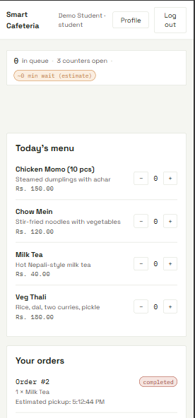

Staff Oder board

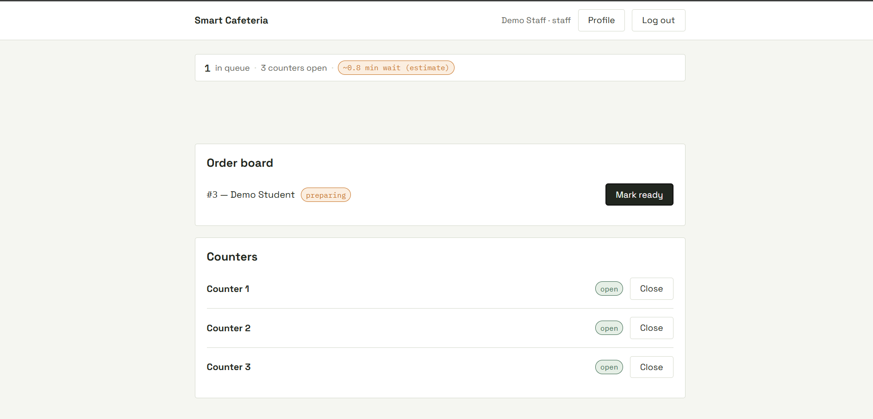

Management Dashboard

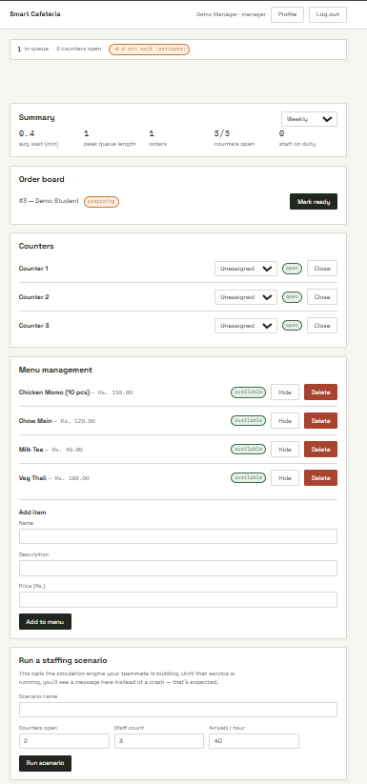

Appendix E — Interview Questions

Yes/no questions used in requirement collection. Answers informed the functional and non-functional requirements in Section 3.
E.1 Students
No. | Question | Answer
1 | Do you usually spend most of the time waiting at the cafeteria during the main break? | Yes
2 | Do you have a way to know the queue length at the cafeteria before you order? | No
3 | Would you use a system that shows estimated wait times in your phone’s browser? | Yes
4 | Would you install a separate app only for the cafeteria? | No
5 | Would you like to pre-order food before the break if it was an option? | Yes
6 | Do you want a notification when your order gets ready for pickup? | Yes
7 | Would you want to track your order status through your phone? | Yes

E.2 Cafeteria staff
No. | Question | Answer
1 | Can the peak-hour rush be predicted with the currently? | No
2 | Would you like a clear board of incoming orders to make it easier to see and track? | Yes
3 | Do you need large, simple buttons to mark an order as received, preparing, ready, or completed? | Yes
4 | Do you need to open or close a counter during service? | Yes
5 | Would a staff-only dashboard with nothing distracting be helpful for you during the rush? | Yes
6 | Do the students currently only learn their food is ready through name callouts? | Yes
7 | Would a live order update on screen reduce the shouting across the counter? | Yes

E.3 Cafeteria manager
No. | Question | Answer
1 | Do you currently decide staffing and counter options from experience rather than historical data? | Yes
2 | Do you think a live queue view and wait times during a break would help you | Yes
3 | Would you use a tool that helps you run demo test before making staff changes in real life? | Yes
4 | Would you find it useful if summarised reports on wait time , queue length and pre-orders were provided to you? | Yes
5 | Should management reports hide individual student identities? | Yes
6 | Would you like the system to show a queue length when the prediction engine is not working or offline? | Yes

E.4 College administrator
No. | Question | Answer
1 | Is student dissatisfaction with cafeteria waiting a concern for the college? | Yes
2 | Do you need reports that show the average wait time and its improvement history overtime? | Yes
3 | Do you think that admin should only see summarized statistics and not a single individual order? | Yes
4 | Is protecting student privacy in management reports a requirement? | Yes

